  Year 3 · Multiplication and division A · Step 10  Divide by 4 | 
  Year 3 · Multiplication and division A · Step 10
  Divide by 4
  1 | Share equally into 4 groups.  a) 12 shared equally into 4 groups =  b) 36 shared equally into 4 groups =  c) 24 shared equally into 4 groups =
  1 | Share equally into 4 groups.  a) 12 shared equally into 4 groups =  b) 36 shared equally into 4 groups =  c) 24 shared equally into 4 groups =
  2 | Make groups of 4.  a) 32 grouped into groups of 4 =  b) 24 grouped into groups of 4 =  c) 36 grouped into groups of 4 =
  2 | Make groups of 4.  a) 32 grouped into groups of 4 =  b) 24 grouped into groups of 4 =  c) 36 grouped into groups of 4 =
  3 | Complete the number sentences to describe the array.  
     | × |  | =
     | × |  | =
     | ÷ |  | =
     | ÷ |  | =
  3 | Complete the number sentences to describe the array.
     | × |  | =
     | × |  | =
     | ÷ |  | =
     | ÷ |  | =
  4 | Work out the divisions.  a) 20 ÷ 4 =  b) 32 ÷ 4 =  c) 36 ÷ 4 =
  4 | Work out the divisions.  a) 20 ÷ 4 =  b) 32 ÷ 4 =  c) 36 ÷ 4 =
  5 | Write the missing number in each calculation.
    a) |  | ÷ 4 | = | 5
    b) | 4 × |  | = | 44
    c) | 32 ÷ 4 | =
  5 | Write the missing number in each calculation.
    a) |  | ÷ 4 | = | 5
    b) | 4 × |  | = | 44
    c) | 32 ÷ 4 | =
  6 | 28 strawberries are shared equally between 4 bowls.  a) How many strawberries are in each bowl?  44 children sit in rows. There are 4 children in each row.  b) How many rows are there?
  6 | 28 strawberries are shared equally between 4 bowls.  a) How many strawberries are in each bowl?  44 children sit in rows. There are 4 children in each row.  b) How many rows are there?
  7 | Complete the number track. It counts down in 4s.  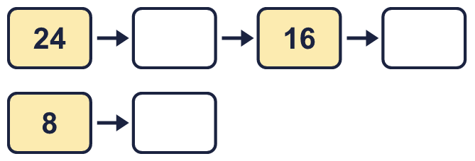
  7 | Complete the number track. It counts down in 4s.
  8 | Kim has 24 sweets. Kim puts the same number in each of 4 plates.  a) How many sweets are in each of the plates?  b) How many sweets are in two of the plates?
  8 | Kim has 24 sweets. Kim puts the same number in each of 4 plates.  a) How many sweets are in each of the plates?  b) How many sweets are in two of the plates?

  9 | Write true or false for each statement.
    a) | 7 × 4 = 6 × 4 + 7
    b) | 7 × 4 = 8 × 4 + 4
    c) | 7 × 4 = 6 × 4 + 4
    d) | 7 × 4 = 8 × 4 - 4
  9 | Write true or false for each statement.
    a) | 7 × 4 = 6 × 4 + 7
    b) | 7 × 4 = 8 × 4 + 4
    c) | 7 × 4 = 6 × 4 + 4
    d) | 7 × 4 = 8 × 4 - 4
  10 | Write <, > or = in each box.
    a) | 12 × 4 |  | 5 × 4
    b) | 4 × 7 |  | 7 × 4
    c) | 48 ÷ 4 |  | 20 ÷ 4
  10 | Write <, > or = in each box.
    a) | 12 × 4 |  | 5 × 4
    b) | 4 × 7 |  | 7 × 4
    c) | 48 ÷ 4 |  | 20 ÷ 4
  11 | Is Boba correct? Circle yes or no.  Yes / No  What is the correct answer?  Explain Boba’s mistake.
    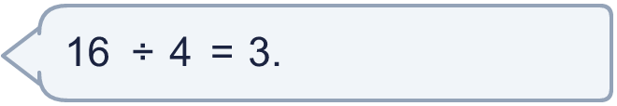
  11 | Is Boba correct? Circle yes or no.  Yes / No  What is the correct answer?  Explain Boba’s mistake.
  12 | There are 4 players in a team. 6 teams have signed up for a tournament.  a) How many players have signed up?  b) The tournament needs 36 players. How many more teams are needed?
  12 | There are 4 players in a team. 6 teams have signed up for a tournament.  a) How many players have signed up?  b) The tournament needs 36 players. How many more teams are needed?
  13 | a) How long is the yellow ribbon?  b) How much longer is the yellow ribbon than the red ribbon?
     | 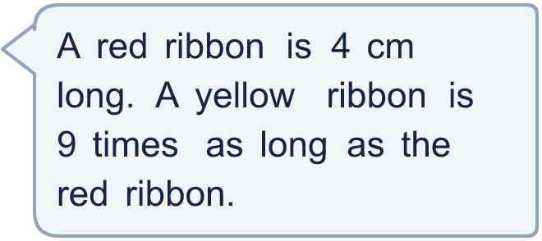
  13 | a) How long is the yellow ribbon?  b) How much longer is the yellow ribbon than the red ribbon?
  14 | Huan is thinking of three different multiples of 4 that are less than 40. The sum of the numbers is 84.  What could the numbers be?
  14 | Huan is thinking of three different multiples of 4 that are less than 40. The sum of the numbers is 84.  What could the numbers be?

Year 3 · Multiplication and division A · Step 10
Divide by 4
Answers (teacher copy)

  1 | Share equally into 4 groups.  a) 12 shared equally into 4 groups = 3  b) 36 shared equally into 4 groups = 9  c) 24 shared equally into 4 groups = 6
  2 | Make groups of 4.  a) 32 grouped into groups of 4 = 8  b) 24 grouped into groups of 4 = 6  c) 36 grouped into groups of 4 = 9
  3 | Complete the number sentences to describe the array.  6 × 4 = 24  4 × 6 = 24  24 ÷ 4 = 6  24 ÷ 6 = 4
  4 | Work out the divisions.  a) 20 ÷ 4 = 5  b) 32 ÷ 4 = 8  c) 36 ÷ 4 = 9
  5 | Write the missing number in each calculation.  a) 20 ÷ 4 = 5  b) 4 × 11 = 44  c) 32 ÷ 4 = 8
  6 | 28 strawberries are shared equally between 4 bowls.  a) How many strawberries are in each bowl? 7  44 children sit in rows. There are 4 children in each row.  b) How many rows are there? 11
  7 | Complete the number track. It counts down in 4s.  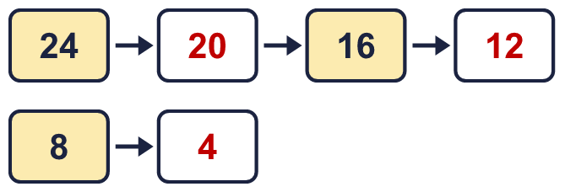
  8 | Kim has 24 sweets. Kim puts the same number in each of 4 plates.  a) How many sweets are in each of the plates? 6  b) How many sweets are in two of the plates? 12
  9 | Write true or false for each statement.  a) 7 × 4 = 6 × 4 + 7 False  b) 7 × 4 = 8 × 4 + 4 False  c) 7 × 4 = 6 × 4 + 4 True  d) 7 × 4 = 8 × 4 - 4 True
  10 | Write <, > or = in each box.  a) 12 × 4 > 5 × 4  b) 4 × 7 = 7 × 4  c) 48 ÷ 4 > 20 ÷ 4
  11 | Is Boba correct? Circle yes or no.  Yes / No  What is the correct answer? 4  Explain Boba’s mistake.  16 ÷ 4 = 4, because 4 groups of 4 make 16.
  12 | There are 4 players in a team. 6 teams have signed up for a tournament.  a) How many players have signed up? 24  b) The tournament needs 36 players. How many more teams are needed? 3
  13 | a) How long is the yellow ribbon? 36 cm  b) How much longer is the yellow ribbon than the red ribbon? 32 cm
  14 | Huan is thinking of three different multiples of 4 that are less than 40. The sum of the numbers is 84.  What could the numbers be?  for example 20 + 28 + 36

