  Year 3 · Multiplication and division A · Step 7  Divide by 3 | 
  Year 3 · Multiplication and division A · Step 7
  Divide by 3
  1 | Share equally into 3 groups.  a) 30 shared equally into 3 groups =  b) 21 shared equally into 3 groups =  c) 15 shared equally into 3 groups =
  1 | Share equally into 3 groups.  a) 30 shared equally into 3 groups =  b) 21 shared equally into 3 groups =  c) 15 shared equally into 3 groups =
  2 | Make groups of 3.  a) 30 grouped into groups of 3 =  b) 12 grouped into groups of 3 =  c) 6 grouped into groups of 3 =
  2 | Make groups of 3.  a) 30 grouped into groups of 3 =  b) 12 grouped into groups of 3 =  c) 6 grouped into groups of 3 =
  3 | Complete the number sentences to describe the array.  
     | × |  | =
     | × |  | =
     | ÷ |  | =
     | ÷ |  | =
  3 | Complete the number sentences to describe the array.
     | × |  | =
     | × |  | =
     | ÷ |  | =
     | ÷ |  | =
  4 | Work out the divisions.  a) 24 ÷ 3 =  b) 33 ÷ 3 =  c) 21 ÷ 3 =
  4 | Work out the divisions.  a) 24 ÷ 3 =  b) 33 ÷ 3 =  c) 21 ÷ 3 =
  5 | Write the missing number in each calculation.
    a) |  | × 3 | = | 15
    b) | 24 ÷ 3 | =
    c) | 3 × |  | = | 30
  5 | Write the missing number in each calculation.
    a) |  | × 3 | = | 15
    b) | 24 ÷ 3 | =
    c) | 3 × |  | = | 30
  6 | 15 strawberries are shared equally between 3 bowls.  a) How many strawberries are in each bowl?  24 children sit in rows. There are 3 children in each row.  b) How many rows are there?
  6 | 15 strawberries are shared equally between 3 bowls.  a) How many strawberries are in each bowl?  24 children sit in rows. There are 3 children in each row.  b) How many rows are there?
  7 | Complete the number track. It counts down in 3s.  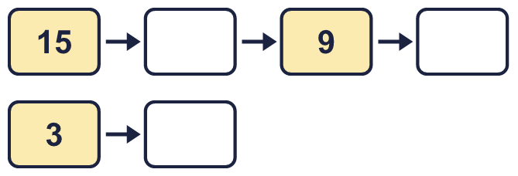
  7 | Complete the number track. It counts down in 3s.
  8 | Mia has 21 apples. Mia puts the same number in each of 3 boxes.  a) How many apples are in each of the boxes?  b) How many apples are in two of the boxes?
  8 | Mia has 21 apples. Mia puts the same number in each of 3 boxes.  a) How many apples are in each of the boxes?  b) How many apples are in two of the boxes?

  9 | Write true or false for each statement.
    a) | 5 × 3 = 4 × 3 + 5
    b) | 5 × 3 = 3 × 5
    c) | 5 × 3 = 4 × 3 + 3
    d) | 5 × 3 = 5 × 4 - 3
  9 | Write true or false for each statement.
    a) | 5 × 3 = 4 × 3 + 5
    b) | 5 × 3 = 3 × 5
    c) | 5 × 3 = 4 × 3 + 3
    d) | 5 × 3 = 5 × 4 - 3
  10 | Write <, > or = in each box.
    a) | 4 × 3 |  | 12 × 3
    b) | 3 × 7 |  | 7 × 3
    c) | 12 ÷ 3 |  | 36 ÷ 3
  10 | Write <, > or = in each box.
    a) | 4 × 3 |  | 12 × 3
    b) | 3 × 7 |  | 7 × 3
    c) | 12 ÷ 3 |  | 36 ÷ 3
  11 | Is Boba correct? Circle yes or no.  Yes / No  What is the correct answer?  Explain Boba’s mistake.
    
  11 | Is Boba correct? Circle yes or no.  Yes / No  What is the correct answer?  Explain Boba’s mistake.
  12 | There are 3 players in a team. 4 teams have signed up for a tournament.  a) How many players have signed up?  b) The tournament needs 18 players. How many more teams are needed?
  12 | There are 3 players in a team. 4 teams have signed up for a tournament.  a) How many players have signed up?  b) The tournament needs 18 players. How many more teams are needed?
  13 | a) How long is the yellow ribbon?  b) How much longer is the yellow ribbon than the red ribbon?
     | 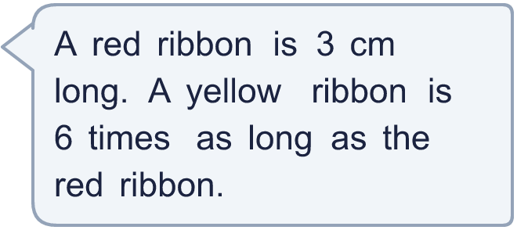
  13 | a) How long is the yellow ribbon?  b) How much longer is the yellow ribbon than the red ribbon?
  14 | Huan is thinking of three different multiples of 3 that are less than 30. The sum of the numbers is 18.  What could the numbers be?
  14 | Huan is thinking of three different multiples of 3 that are less than 30. The sum of the numbers is 18.  What could the numbers be?

Year 3 · Multiplication and division A · Step 7
Divide by 3
Answers (teacher copy)

  1 | Share equally into 3 groups.  a) 30 shared equally into 3 groups = 10  b) 21 shared equally into 3 groups = 7  c) 15 shared equally into 3 groups = 5
  2 | Make groups of 3.  a) 30 grouped into groups of 3 = 10  b) 12 grouped into groups of 3 = 4  c) 6 grouped into groups of 3 = 2
  3 | Complete the number sentences to describe the array.  6 × 3 = 18  3 × 6 = 18  18 ÷ 3 = 6  18 ÷ 6 = 3
  4 | Work out the divisions.  a) 24 ÷ 3 = 8  b) 33 ÷ 3 = 11  c) 21 ÷ 3 = 7
  5 | Write the missing number in each calculation.  a) 5 × 3 = 15  b) 24 ÷ 3 = 8  c) 3 × 10 = 30
  6 | 15 strawberries are shared equally between 3 bowls.  a) How many strawberries are in each bowl? 5  24 children sit in rows. There are 3 children in each row.  b) How many rows are there? 8
  7 | Complete the number track. It counts down in 3s.  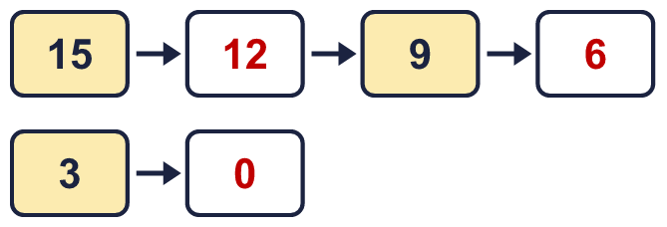
  8 | Mia has 21 apples. Mia puts the same number in each of 3 boxes.  a) How many apples are in each of the boxes? 7  b) How many apples are in two of the boxes? 14
  9 | Write true or false for each statement.  a) 5 × 3 = 4 × 3 + 5 False  b) 5 × 3 = 3 × 5 True  c) 5 × 3 = 4 × 3 + 3 True  d) 5 × 3 = 5 × 4 - 3 False
  10 | Write <, > or = in each box.  a) 4 × 3 < 12 × 3  b) 3 × 7 = 7 × 3  c) 12 ÷ 3 < 36 ÷ 3
  11 | Is Boba correct? Circle yes or no.  Yes / No  What is the correct answer? 7  Explain Boba’s mistake.  21 ÷ 3 = 7, because 7 groups of 3 make 21.
  12 | There are 3 players in a team. 4 teams have signed up for a tournament.  a) How many players have signed up? 12  b) The tournament needs 18 players. How many more teams are needed? 2
  13 | a) How long is the yellow ribbon? 18 cm  b) How much longer is the yellow ribbon than the red ribbon? 15 cm
  14 | Huan is thinking of three different multiples of 3 that are less than 30. The sum of the numbers is 18.  What could the numbers be?  for example 3 + 6 + 9

