  Year 3 · Addition and subtraction · Step 12  Subtract two numbers with no exchange | 
  Year 3 · Addition and subtraction · Step 12
  Subtract two numbers with no exchange
  1 | Complete the column subtraction. Write the missing digits in the answer.  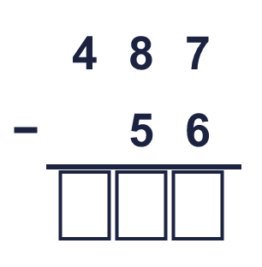
  1 | Complete the column subtraction. Write the missing digits in the answer.
  2 | Work out the subtractions.  a) 89 − 81 =  b) 56 − 13 =  c) 43 − 33 =
  2 | Work out the subtractions.  a) 89 − 81 =  b) 56 − 13 =  c) 43 − 33 =
  3 | Work out the subtractions.  a) 999 − 475 =  b) 657 − 146 =  c) 869 − 245 =
  3 | Work out the subtractions.  a) 999 − 475 =  b) 657 − 146 =  c) 869 − 245 =
  4 | Complete the column subtraction. Write the missing digits in the answer.  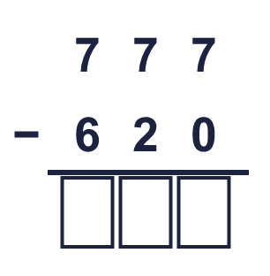
  4 | Complete the column subtraction. Write the missing digits in the answer.
  5 | Write the missing digits in the calculation.  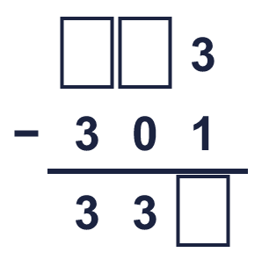
  5 | Write the missing digits in the calculation.
  6 | Work out the calculations. Write the units in your answer.  a) £896 − £874 =  b) 330 cm − 300 cm =  c) 568 ml − 544 ml =
  6 | Work out the calculations. Write the units in your answer.  a) £896 − £874 =  b) 330 cm − 300 cm =  c) 568 ml − 544 ml =
  7 | Sam has 232 books. Sam gives away 10 of them.  How many books does Sam have left?
  7 | Sam has 232 books. Sam gives away 10 of them.  How many books does Sam have left?
  8 | Look at the bar model. Subtract to find the missing part.  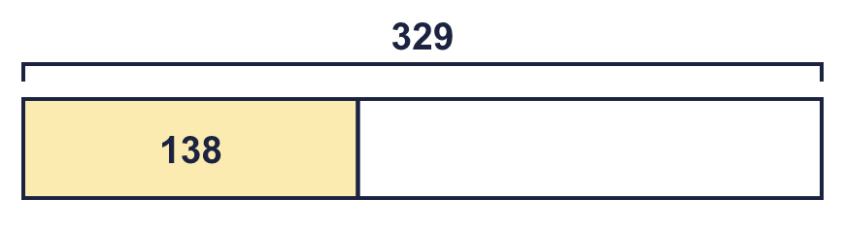
  8 | Look at the bar model. Subtract to find the missing part.

  9 | Is each calculation correct? Circle yes or no.  a) 892 + 70 = 963  Yes / No  b) 859 − 99 = 760  Yes / No  c) 767 + 25 = 792  Yes / No
  9 | Is each calculation correct? Circle yes or no.  a) 892 + 70 = 963  Yes / No  b) 859 − 99 = 760  Yes / No  c) 767 + 25 = 792  Yes / No
  10 | Is Boba correct? Circle yes or no.  Yes / No  What is the correct answer?  Explain the mistake.
     | 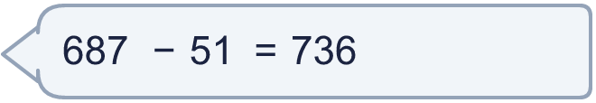
  10 | Is Boba correct? Circle yes or no.  Yes / No  What is the correct answer?  Explain the mistake.
  11 | What number did I think of?
    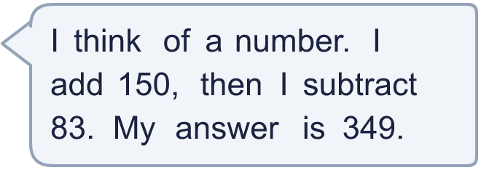
  11 | What number did I think of?
  12 | Write two different subtractions with an answer of exactly 250. Each has a 3-digit number and a 2-digit number.
  12 | Write two different subtractions with an answer of exactly 250. Each has a 3-digit number and a 2-digit number.
  13 | Dora has 369 cards. Tia has 61 fewer cards than Dora.  a) How many cards does Tia have?  b) How many cards do they have altogether?
  13 | Dora has 369 cards. Tia has 61 fewer cards than Dora.  a) How many cards does Tia have?  b) How many cards do they have altogether?
  14 | 673 − 560 = 113. Write the addition that checks it.  113 + 560 =
  14 | 673 − 560 = 113. Write the addition that checks it.  113 + 560 =

Year 3 · Addition and subtraction · Step 12
Subtract two numbers with no exchange
Answers (teacher copy)

  1 | Complete the column subtraction. Write the missing digits in the answer.  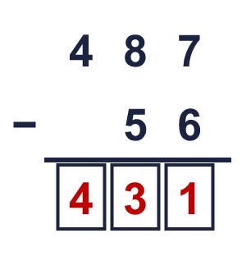  Answer: 431
  2 | Work out the subtractions.  a) 89 − 81 = 8  b) 56 − 13 = 43  c) 43 − 33 = 10
  3 | Work out the subtractions.  a) 999 − 475 = 524  b) 657 − 146 = 511  c) 869 − 245 = 624
  4 | Complete the column subtraction. Write the missing digits in the answer.  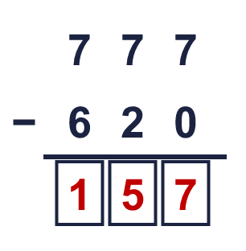  Answer: 157
  5 | Write the missing digits in the calculation.  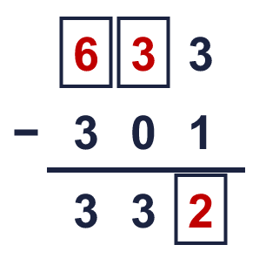  Missing digits, from top to bottom and left to right: 6 3 2
  6 | Work out the calculations. Write the units in your answer.  a) £896 − £874 = £22  b) 330 cm − 300 cm = 30 cm  c) 568 ml − 544 ml = 24 ml
  7 | Sam has 232 books. Sam gives away 10 of them.  How many books does Sam have left? 222
  8 | Look at the bar model. Subtract to find the missing part.  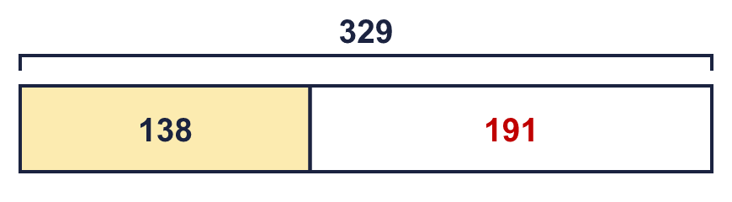  The missing part is 191
  9 | Is each calculation correct? Circle yes or no.  a) 892 + 70 = 963  Yes / No  b) 859 − 99 = 760  Yes / No  c) 767 + 25 = 792  Yes / No
  10 | Is Boba correct? Circle yes or no.  Yes / No  What is the correct answer? 636  Explain the mistake.  687 − 51 = 636. The answer 736 is too big by 100.
  11 | What number did I think of? 282
  12 | Write two different subtractions with an answer of exactly 250. Each has a 3-digit number and a 2-digit number.  for example 272 − 22 and 304 − 54
  13 | Dora has 369 cards. Tia has 61 fewer cards than Dora.  a) How many cards does Tia have? 308  b) How many cards do they have altogether? 677
  14 | 673 − 560 = 113. Write the addition that checks it.  113 + 560 = 673

