  Year 3 · Addition and subtraction · Step 16  Subtract two numbers across a 100 | 
  Year 3 · Addition and subtraction · Step 16
  Subtract two numbers across a 100
  1 | Complete the column subtraction. Write the missing digits in the answer.  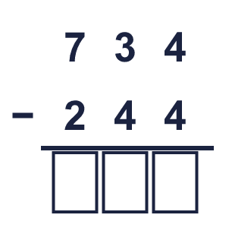
  1 | Complete the column subtraction. Write the missing digits in the answer.
  2 | Work out the subtractions.  a) 562 − 470 =  b) 836 − 142 =  c) 605 − 483 =
  2 | Work out the subtractions.  a) 562 − 470 =  b) 836 − 142 =  c) 605 − 483 =
  3 | Work out the subtractions.  a) 816 − 51 =  b) 149 − 87 =  c) 252 − 70 =
  3 | Work out the subtractions.  a) 816 − 51 =  b) 149 − 87 =  c) 252 − 70 =
  4 | Complete the column subtraction. Write the missing digits in the answer.  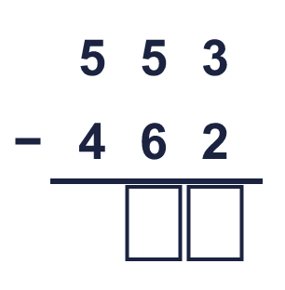
  4 | Complete the column subtraction. Write the missing digits in the answer.
  5 | Write the missing digits in the calculation.  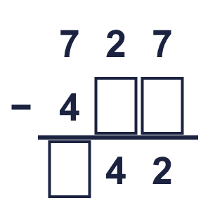
  5 | Write the missing digits in the calculation.
  6 | Work out the calculations. Write the units in your answer.  a) 843 ml − 150 ml =  b) £814 − £564 =  c) 761 g − 191 g =
  6 | Work out the calculations. Write the units in your answer.  a) 843 ml − 150 ml =  b) £814 − £564 =  c) 761 g − 191 g =
  7 | Nina has 236 stickers. Nina gives away 55 of them.  How many stickers does Nina have left?
  7 | Nina has 236 stickers. Nina gives away 55 of them.  How many stickers does Nina have left?
  8 | Look at the bar model. Subtract to find the missing part.  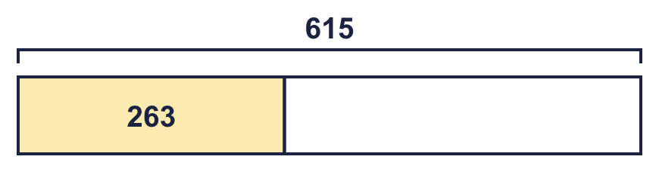
  8 | Look at the bar model. Subtract to find the missing part.

  9 | Is each calculation correct? Circle yes or no.  a) 799 + 34 = 833  Yes / No  b) 881 − 25 = 856  Yes / No  c) 880 + 51 = 941  Yes / No
  9 | Is each calculation correct? Circle yes or no.  a) 799 + 34 = 833  Yes / No  b) 881 − 25 = 856  Yes / No  c) 880 + 51 = 941  Yes / No
  10 | Is Boba correct? Circle yes or no.  Yes / No  What is the correct answer?  Explain the mistake.
     | 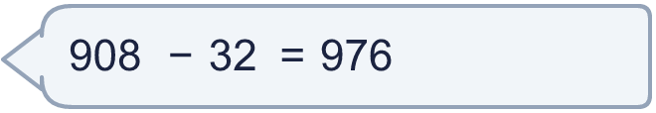
  10 | Is Boba correct? Circle yes or no.  Yes / No  What is the correct answer?  Explain the mistake.
  11 | What number did I think of?
    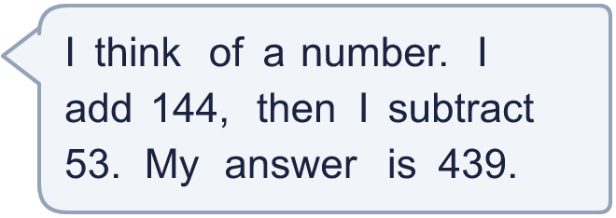
  11 | What number did I think of?
  12 | Write two different subtractions with an answer of exactly 250. Each has a 3-digit number and a 2-digit number.
  12 | Write two different subtractions with an answer of exactly 250. Each has a 3-digit number and a 2-digit number.
  13 | Mia has 330 balloons. Alex has 127 fewer balloons than Mia.  a) How many balloons does Alex have?  b) How many balloons do they have altogether?
  13 | Mia has 330 balloons. Alex has 127 fewer balloons than Mia.  a) How many balloons does Alex have?  b) How many balloons do they have altogether?
  14 | 523 − 179 = 344. Write the addition that checks it.  344 + 179 =
  14 | 523 − 179 = 344. Write the addition that checks it.  344 + 179 =

Year 3 · Addition and subtraction · Step 16
Subtract two numbers across a 100
Answers (teacher copy)

  1 | Complete the column subtraction. Write the missing digits in the answer.  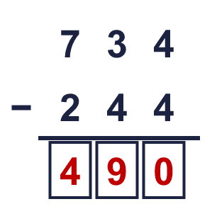  Answer: 490
  2 | Work out the subtractions.  a) 562 − 470 = 92  b) 836 − 142 = 694  c) 605 − 483 = 122
  3 | Work out the subtractions.  a) 816 − 51 = 765  b) 149 − 87 = 62  c) 252 − 70 = 182
  4 | Complete the column subtraction. Write the missing digits in the answer.  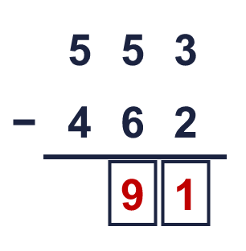  Answer: 91
  5 | Write the missing digits in the calculation.  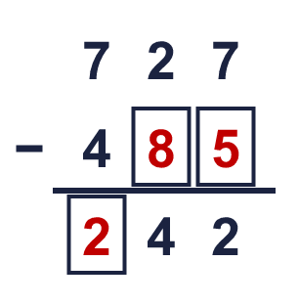  Missing digits, from top to bottom and left to right: 8 5 2
  6 | Work out the calculations. Write the units in your answer.  a) 843 ml − 150 ml = 693 ml  b) £814 − £564 = £250  c) 761 g − 191 g = 570 g
  7 | Nina has 236 stickers. Nina gives away 55 of them.  How many stickers does Nina have left? 181
  8 | Look at the bar model. Subtract to find the missing part.  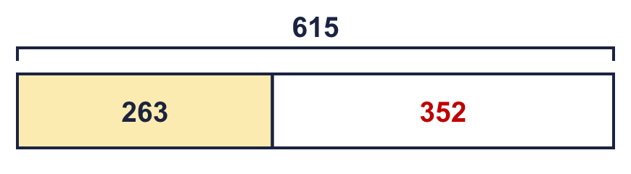  The missing part is 352
  9 | Is each calculation correct? Circle yes or no.  a) 799 + 34 = 833  Yes / No  b) 881 − 25 = 856  Yes / No  c) 880 + 51 = 941  Yes / No
  10 | Is Boba correct? Circle yes or no.  Yes / No  What is the correct answer? 876  Explain the mistake.  908 − 32 = 876. The answer 976 is too big by 100.
  11 | What number did I think of? 348
  12 | Write two different subtractions with an answer of exactly 250. Each has a 3-digit number and a 2-digit number.  for example 272 − 22 and 304 − 54
  13 | Mia has 330 balloons. Alex has 127 fewer balloons than Mia.  a) How many balloons does Alex have? 203  b) How many balloons do they have altogether? 533
  14 | 523 − 179 = 344. Write the addition that checks it.  344 + 179 = 523

