  Year 3 · Addition and subtraction · Step 15  Subtract two numbers across a 10 | 
  Year 3 · Addition and subtraction · Step 15
  Subtract two numbers across a 10
  1 | Complete the column subtraction. Write the missing digits in the answer.  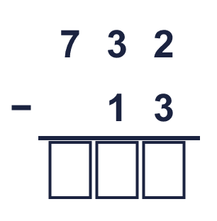
  1 | Complete the column subtraction. Write the missing digits in the answer.
  2 | Work out the subtractions.  a) 43 − 25 =  b) 64 − 55 =  c) 53 − 44 =
  2 | Work out the subtractions.  a) 43 − 25 =  b) 64 − 55 =  c) 53 − 44 =
  3 | Work out the subtractions.  a) 490 − 242 =  b) 590 − 232 =  c) 894 − 215 =
  3 | Work out the subtractions.  a) 490 − 242 =  b) 590 − 232 =  c) 894 − 215 =
  4 | Complete the column subtraction. Write the missing digits in the answer.  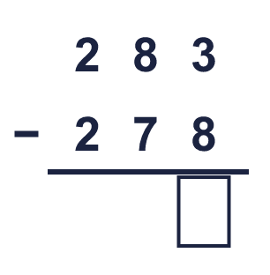
  4 | Complete the column subtraction. Write the missing digits in the answer.
  5 | Write the missing digits in the calculation.  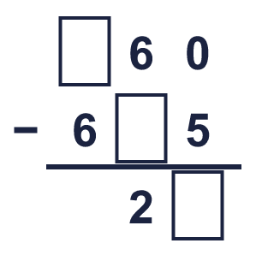
  5 | Write the missing digits in the calculation.
  6 | Work out the calculations. Write the units in your answer.  a) £748 − £739 =  b) 754 kg − 625 kg =  c) 981 m − 133 m =
  6 | Work out the calculations. Write the units in your answer.  a) £748 − £739 =  b) 754 kg − 625 kg =  c) 981 m − 133 m =
  7 | Eva has 432 stamps. Eva gives away 15 of them.  How many stamps does Eva have left?
  7 | Eva has 432 stamps. Eva gives away 15 of them.  How many stamps does Eva have left?
  8 | Look at the bar model. Subtract to find the missing part.  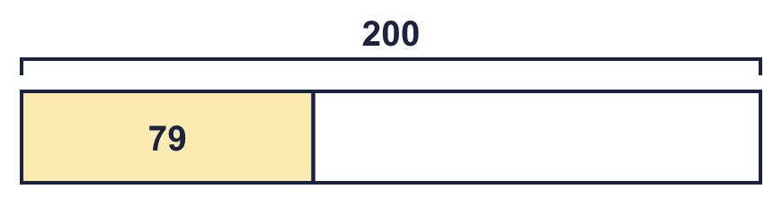
  8 | Look at the bar model. Subtract to find the missing part.

  9 | Is each calculation correct? Circle yes or no.  a) 134 + 59 = 194  Yes / No  b) 561 + 64 = 725  Yes / No  c) 698 + 41 = 739  Yes / No
  9 | Is each calculation correct? Circle yes or no.  a) 134 + 59 = 194  Yes / No  b) 561 + 64 = 725  Yes / No  c) 698 + 41 = 739  Yes / No
  10 | Is Boba correct? Circle yes or no.  Yes / No  What is the correct answer?  Explain the mistake.
     | 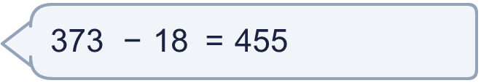
  10 | Is Boba correct? Circle yes or no.  Yes / No  What is the correct answer?  Explain the mistake.
  11 | What number did I think of?
    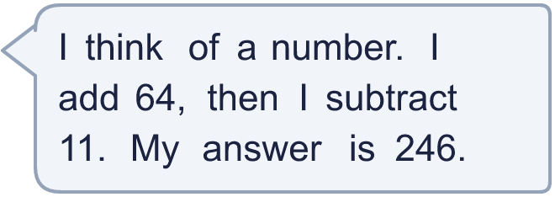
  11 | What number did I think of?
  12 | Write two different subtractions with an answer of exactly 250. Each has a 3-digit number and a 2-digit number.
  12 | Write two different subtractions with an answer of exactly 250. Each has a 3-digit number and a 2-digit number.
  13 | Zach has 319 stamps. Mo has 127 fewer stamps than Zach.  a) How many stamps does Mo have?  b) How many stamps do they have altogether?
  13 | Zach has 319 stamps. Mo has 127 fewer stamps than Zach.  a) How many stamps does Mo have?  b) How many stamps do they have altogether?
  14 | 522 − 279 = 243. Write the addition that checks it.  243 + 279 =
  14 | 522 − 279 = 243. Write the addition that checks it.  243 + 279 =

Year 3 · Addition and subtraction · Step 15
Subtract two numbers across a 10
Answers (teacher copy)

  1 | Complete the column subtraction. Write the missing digits in the answer.  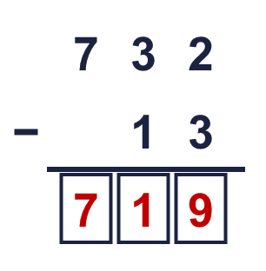  Answer: 719
  2 | Work out the subtractions.  a) 43 − 25 = 18  b) 64 − 55 = 9  c) 53 − 44 = 9
  3 | Work out the subtractions.  a) 490 − 242 = 248  b) 590 − 232 = 358  c) 894 − 215 = 679
  4 | Complete the column subtraction. Write the missing digits in the answer.  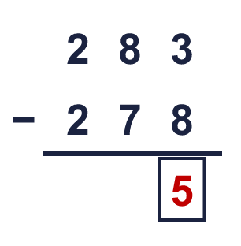  Answer: 5
  5 | Write the missing digits in the calculation.  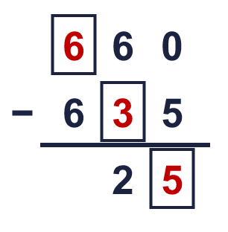  Missing digits, from top to bottom and left to right: 6 3 5
  6 | Work out the calculations. Write the units in your answer.  a) £748 − £739 = £9  b) 754 kg − 625 kg = 129 kg  c) 981 m − 133 m = 848 m
  7 | Eva has 432 stamps. Eva gives away 15 of them.  How many stamps does Eva have left? 417
  8 | Look at the bar model. Subtract to find the missing part.  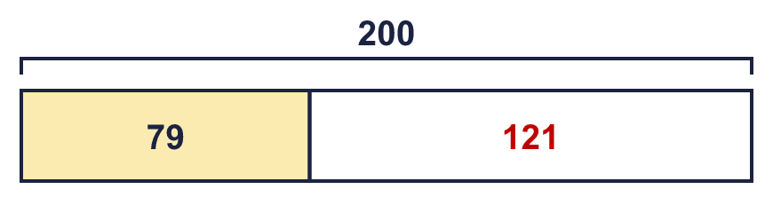  The missing part is 121
  9 | Is each calculation correct? Circle yes or no.  a) 134 + 59 = 194  Yes / No  b) 561 + 64 = 725  Yes / No  c) 698 + 41 = 739  Yes / No
  10 | Is Boba correct? Circle yes or no.  Yes / No  What is the correct answer? 355  Explain the mistake.  373 − 18 = 355. The answer 455 is too big by 100.
  11 | What number did I think of? 193
  12 | Write two different subtractions with an answer of exactly 250. Each has a 3-digit number and a 2-digit number.  for example 272 − 22 and 304 − 54
  13 | Zach has 319 stamps. Mo has 127 fewer stamps than Zach.  a) How many stamps does Mo have? 192  b) How many stamps do they have altogether? 511
  14 | 522 − 279 = 243. Write the addition that checks it.  243 + 279 = 522

