  Year 3 · Addition and subtraction · Step 18  Subtract a 2-digit number from a 3-digit number | 
  Year 3 · Addition and subtraction · Step 18
  Subtract a 2-digit number from a 3-digit number
  1 | Complete the column subtraction. Write the missing digits in the answer.  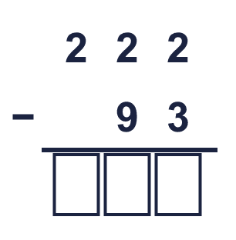
  1 | Complete the column subtraction. Write the missing digits in the answer.
  2 | Work out the subtractions.  a) 270 − 67 =  b) 750 − 48 =  c) 271 − 45 =
  2 | Work out the subtractions.  a) 270 − 67 =  b) 750 − 48 =  c) 271 − 45 =
  3 | Work out the subtractions.  a) 335 − 90 =  b) 608 − 60 =  c) 649 − 93 =
  3 | Work out the subtractions.  a) 335 − 90 =  b) 608 − 60 =  c) 649 − 93 =
  4 | Work out the subtractions.  a) 406 − 58 =  b) 171 − 84 =  c) 151 − 85 =
  4 | Work out the subtractions.  a) 406 − 58 =  b) 171 − 84 =  c) 151 − 85 =
  5 | Write the missing digits in the calculation.  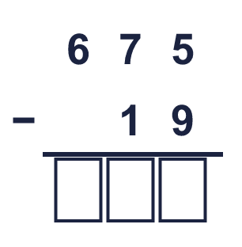
  5 | Write the missing digits in the calculation.
  6 | Work out the calculations. Write the units in your answer.  a) 318 m − 54 m =  b) 603 cm − 61 cm =  c) 831 ml − 53 ml =
  6 | Work out the calculations. Write the units in your answer.  a) 318 m − 54 m =  b) 603 cm − 61 cm =  c) 831 ml − 53 ml =
  7 | Sam has 184 books. Sam gives away 39 of them.  How many books does Sam have left?
  7 | Sam has 184 books. Sam gives away 39 of them.  How many books does Sam have left?
  8 | Look at the bar model. Subtract to find the missing part.  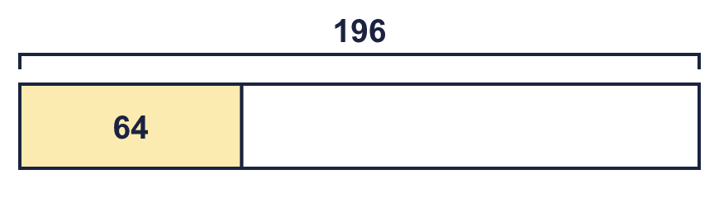
  8 | Look at the bar model. Subtract to find the missing part.

  9 | Is each calculation correct? Circle yes or no.  a) 790 − 24 = 766  Yes / No  b) 628 − 76 = 552  Yes / No  c) 250 − 42 = 108  Yes / No
  9 | Is each calculation correct? Circle yes or no.  a) 790 − 24 = 766  Yes / No  b) 628 − 76 = 552  Yes / No  c) 250 − 42 = 108  Yes / No
  10 | Is Boba correct? Circle yes or no.  Yes / No  What is the correct answer?  Explain the mistake.
     | 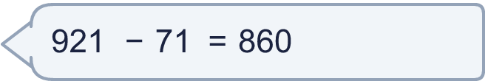
  10 | Is Boba correct? Circle yes or no.  Yes / No  What is the correct answer?  Explain the mistake.
  11 | What number did I think of?
    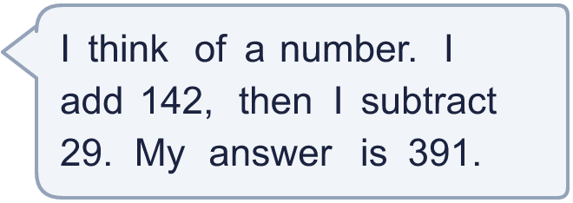
  11 | What number did I think of?
  12 | Write two different subtractions with an answer of exactly 250. Each has a 3-digit number and a 2-digit number.
  12 | Write two different subtractions with an answer of exactly 250. Each has a 3-digit number and a 2-digit number.
  13 | Filip has 464 balloons. Kim has 33 fewer balloons than Filip.  a) How many balloons does Kim have?  b) How many balloons do they have altogether?
  13 | Filip has 464 balloons. Kim has 33 fewer balloons than Filip.  a) How many balloons does Kim have?  b) How many balloons do they have altogether?
  14 | 527 − 181 = 346. Write the addition that checks it.  346 + 181 =
  14 | 527 − 181 = 346. Write the addition that checks it.  346 + 181 =

Year 3 · Addition and subtraction · Step 18
Subtract a 2-digit number from a 3-digit number
Answers (teacher copy)

  1 | Complete the column subtraction. Write the missing digits in the answer.  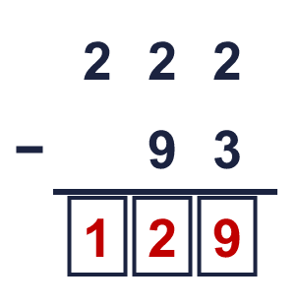  Answer: 129
  2 | Work out the subtractions.  a) 270 − 67 = 203  b) 750 − 48 = 702  c) 271 − 45 = 226
  3 | Work out the subtractions.  a) 335 − 90 = 245  b) 608 − 60 = 548  c) 649 − 93 = 556
  4 | Work out the subtractions.  a) 406 − 58 = 348  b) 171 − 84 = 87  c) 151 − 85 = 66
  5 | Write the missing digits in the calculation.  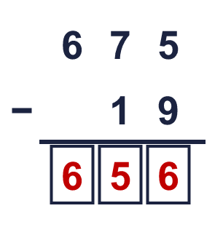  Missing digits, from top to bottom and left to right: 6 5 6
  6 | Work out the calculations. Write the units in your answer.  a) 318 m − 54 m = 264 m  b) 603 cm − 61 cm = 542 cm  c) 831 ml − 53 ml = 778 ml
  7 | Sam has 184 books. Sam gives away 39 of them.  How many books does Sam have left? 145
  8 | Look at the bar model. Subtract to find the missing part.  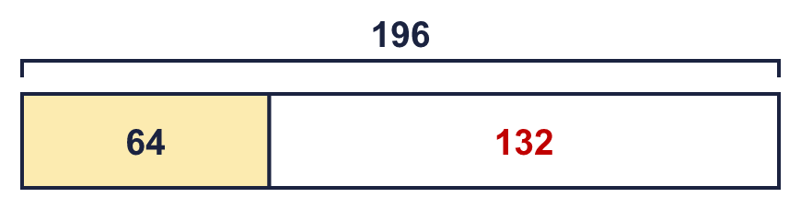  The missing part is 132
  9 | Is each calculation correct? Circle yes or no.  a) 790 − 24 = 766  Yes / No  b) 628 − 76 = 552  Yes / No  c) 250 − 42 = 108  Yes / No
  10 | Is Boba correct? Circle yes or no.  Yes / No  What is the correct answer? 850  Explain the mistake.  921 − 71 = 850. The answer 860 is too big by 10.
  11 | What number did I think of? 278
  12 | Write two different subtractions with an answer of exactly 250. Each has a 3-digit number and a 2-digit number.  for example 272 − 22 and 304 − 54
  13 | Filip has 464 balloons. Kim has 33 fewer balloons than Filip.  a) How many balloons does Kim have? 431  b) How many balloons do they have altogether? 895
  14 | 527 − 181 = 346. Write the addition that checks it.  346 + 181 = 527

