  Year 3 · Addition and subtraction · Step 8  Subtract 1s across a 10 | 
  Year 3 · Addition and subtraction · Step 8
  Subtract 1s across a 10
  1 | Work out the calculations.  a) 430 − 9 =  b) 293 − 8 =  c) 370 − 6 =
  1 | Work out the calculations.  a) 430 − 9 =  b) 293 − 8 =  c) 370 − 6 =
  2 | Work out the calculations.  a) 720 − 4 =  b) 392 − 5 =  c) 541 − 6 =  d) 681 − 8 =
  2 | Work out the calculations.  a) 720 − 4 =  b) 392 − 5 =  c) 541 − 6 =  d) 681 − 8 =
  3 | Write the missing number in each calculation.
    a) | 303 − |  | = 300
    b) | 414 − |  | = 410
    c) | 314 − |  | = 310
  3 | Write the missing number in each calculation.
    a) | 303 − |  | = 300
    b) | 414 − |  | = 410
    c) | 314 − |  | = 310
  4 | Work out the subtractions.  a) 590 − 4 =  b) 680 − 4 =  c) 157 − 9 =
  4 | Work out the subtractions.  a) 590 − 4 =  b) 680 − 4 =  c) 157 − 9 =
  5 | Work out the calculations.  a) 387 + 9 =  b) 709 + 9 =  c) 701 − 8 =  d) 950 − 8 =
  5 | Work out the calculations.  a) 387 + 9 =  b) 709 + 9 =  c) 701 − 8 =  d) 950 − 8 =
  6 | Filip has 770 shells. Filip gives away 2 of them.  How many shells does Filip have left?
  6 | Filip has 770 shells. Filip gives away 2 of them.  How many shells does Filip have left?
  7 | Work out the calculations. Write the units in your answer.  a) 984 m − 6 m =  b) 535 g − 7 g =  c) 960 kg − 2 kg =
  7 | Work out the calculations. Write the units in your answer.  a) 984 m − 6 m =  b) 535 g − 7 g =  c) 960 kg − 2 kg =
  8 | Count back in 1s. Write the missing numbers.
    305, |  | , |  | , | 302, | 301,
  8 | Count back in 1s. Write the missing numbers.
    305, |  | , |  | , | 302, | 301,

  9 | Is each calculation correct? Circle yes or no.  a) 340 − 8 = 332  Yes / No  b) 853 − 6 = 846  Yes / No  c) 687 + 5 = 592  Yes / No
  9 | Is each calculation correct? Circle yes or no.  a) 340 − 8 = 332  Yes / No  b) 853 − 6 = 846  Yes / No  c) 687 + 5 = 592  Yes / No
  10 | Is Boba correct? Circle yes or no.  Yes / No  What is the correct answer?  Explain the mistake.
     | 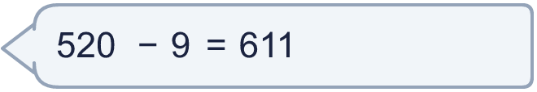
  10 | Is Boba correct? Circle yes or no.  Yes / No  What is the correct answer?  Explain the mistake.
  11 | What number did I think of?
    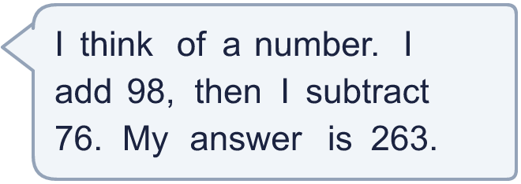
  11 | What number did I think of?
  12 | Write two different subtractions with an answer of exactly 250. Each has a 3-digit number and a 1-digit number.
  12 | Write two different subtractions with an answer of exactly 250. Each has a 3-digit number and a 1-digit number.
  13 | Dora has 409 pencils. Mo has 52 fewer pencils than Dora.  a) How many pencils does Mo have?  b) How many pencils do they have altogether?
  13 | Dora has 409 pencils. Mo has 52 fewer pencils than Dora.  a) How many pencils does Mo have?  b) How many pencils do they have altogether?
  14 | Tia uses an addition to check a subtraction. Is the subtraction correct? Circle yes or no.  354 − 113 = 241  Yes / No  Explain how you know.
  14 | Tia uses an addition to check a subtraction. Is the subtraction correct? Circle yes or no.  354 − 113 = 241  Yes / No  Explain how you know.

Year 3 · Addition and subtraction · Step 8
Subtract 1s across a 10
Answers (teacher copy)

  1 | Work out the calculations.  a) 430 − 9 = 421  b) 293 − 8 = 285  c) 370 − 6 = 364
  2 | Work out the calculations.  a) 720 − 4 = 716  b) 392 − 5 = 387  c) 541 − 6 = 535  d) 681 − 8 = 673
  3 | Write the missing number in each calculation.  a) 303 − 3 = 300  b) 414 − 4 = 410  c) 314 − 4 = 310
  4 | Work out the subtractions.  a) 590 − 4 = 586  b) 680 − 4 = 676  c) 157 − 9 = 148
  5 | Work out the calculations.  a) 387 + 9 = 396  b) 709 + 9 = 718  c) 701 − 8 = 693  d) 950 − 8 = 942
  6 | Filip has 770 shells. Filip gives away 2 of them.  How many shells does Filip have left? 768
  7 | Work out the calculations. Write the units in your answer.  a) 984 m − 6 m = 978 m  b) 535 g − 7 g = 528 g  c) 960 kg − 2 kg = 958 kg
  8 | Count back in 1s. Write the missing numbers.  305, 304 , 303 , 302, 301, 300
  9 | Is each calculation correct? Circle yes or no.  a) 340 − 8 = 332  Yes / No  b) 853 − 6 = 846  Yes / No  c) 687 + 5 = 592  Yes / No
  10 | Is Boba correct? Circle yes or no.  Yes / No  What is the correct answer? 511  Explain the mistake.  520 − 9 = 511. The answer 611 is too big by 100.
  11 | What number did I think of? 241
  12 | Write two different subtractions with an answer of exactly 250. Each has a 3-digit number and a 1-digit number.  for example 253 − 3 and 257 − 7
  13 | Dora has 409 pencils. Mo has 52 fewer pencils than Dora.  a) How many pencils does Mo have? 357  b) How many pencils do they have altogether? 766
  14 | Tia uses an addition to check a subtraction. Is the subtraction correct? Circle yes or no.  354 − 113 = 241  Yes / No  Explain how you know.  241 + 113 = 354, so 354 − 113 = 241.

