  Year 3 · Addition and subtraction · Step 9  Subtract 10s across a 100 | 
  Year 3 · Addition and subtraction · Step 9
  Subtract 10s across a 100
  1 | Work out the calculations.  a) 811 − 40 =  b) 509 − 10 =  c) 778 − 80 =
  1 | Work out the calculations.  a) 811 − 40 =  b) 509 − 10 =  c) 778 − 80 =
  2 | Work out the calculations.  a) 272 − 90 =  b) 836 − 40 =  c) 707 − 80 =  d) 735 − 60 =
  2 | Work out the calculations.  a) 272 − 90 =  b) 836 − 40 =  c) 707 − 80 =  d) 735 − 60 =
  3 | Write the missing number in each calculation.
    a) | 713 − |  | = 700
    b) | 448 − |  | = 400
    c) | 319 − |  | = 300
  3 | Write the missing number in each calculation.
    a) | 713 − |  | = 700
    b) | 448 − |  | = 400
    c) | 319 − |  | = 300
  4 | Work out the subtractions.  a) 268 − 84 =  b) 845 − 95 =  c) 717 − 50 =
  4 | Work out the subtractions.  a) 268 − 84 =  b) 845 − 95 =  c) 717 − 50 =
  5 | Work out the calculations.  a) 233 + 90 =  b) 257 + 70 =  c) 738 − 60 =  d) 711 − 20 =
  5 | Work out the calculations.  a) 233 + 90 =  b) 257 + 70 =  c) 738 − 60 =  d) 711 − 20 =
  6 | Zach has 885 beads. Zach gives away 95 of them.  How many beads does Zach have left?
  6 | Zach has 885 beads. Zach gives away 95 of them.  How many beads does Zach have left?
  7 | Work out the calculations. Write the units in your answer.  a) 806 kg − 10 kg =  b) 684 cm − 92 cm =  c) 913 m − 32 m =
  7 | Work out the calculations. Write the units in your answer.  a) 806 kg − 10 kg =  b) 684 cm − 92 cm =  c) 913 m − 32 m =
  8 | Count back in 10s. Write the missing numbers.
    355, |  | , |  | , |  | , | 315, | 305
  8 | Count back in 10s. Write the missing numbers.
    355, |  | , |  | , |  | , | 315, | 305

  9 | Is each calculation correct? Circle yes or no.  a) 200 − 35 = 175  Yes / No  b) 829 − 88 = 741  Yes / No  c) 231 − 88 = 133  Yes / No
  9 | Is each calculation correct? Circle yes or no.  a) 200 − 35 = 175  Yes / No  b) 829 − 88 = 741  Yes / No  c) 231 − 88 = 133  Yes / No
  10 | Is Boba correct? Circle yes or no.  Yes / No  What is the correct answer?  Explain the mistake.
     | 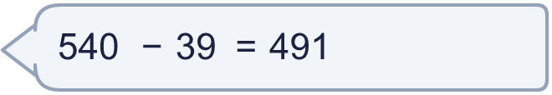
  10 | Is Boba correct? Circle yes or no.  Yes / No  What is the correct answer?  Explain the mistake.
  11 | What number did I think of?
    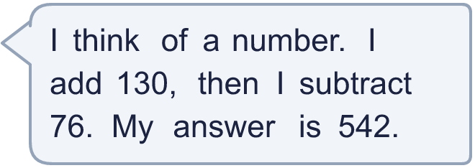
  11 | What number did I think of?
  12 | Write two different subtractions with an answer of exactly 200. Each has a 3-digit number and a 2-digit number.
  12 | Write two different subtractions with an answer of exactly 200. Each has a 3-digit number and a 2-digit number.
  13 | Alex has 278 stamps. Kim has 162 fewer stamps than Alex.  a) How many stamps does Kim have?  b) How many stamps do they have altogether?
  13 | Alex has 278 stamps. Kim has 162 fewer stamps than Alex.  a) How many stamps does Kim have?  b) How many stamps do they have altogether?
  14 | Mo uses an addition to check a subtraction. Is the subtraction correct? Circle yes or no.  854 − 557 = 297  Yes / No  Explain how you know.
  14 | Mo uses an addition to check a subtraction. Is the subtraction correct? Circle yes or no.  854 − 557 = 297  Yes / No  Explain how you know.

Year 3 · Addition and subtraction · Step 9
Subtract 10s across a 100
Answers (teacher copy)

  1 | Work out the calculations.  a) 811 − 40 = 771  b) 509 − 10 = 499  c) 778 − 80 = 698
  2 | Work out the calculations.  a) 272 − 90 = 182  b) 836 − 40 = 796  c) 707 − 80 = 627  d) 735 − 60 = 675
  3 | Write the missing number in each calculation.  a) 713 − 13 = 700  b) 448 − 48 = 400  c) 319 − 19 = 300
  4 | Work out the subtractions.  a) 268 − 84 = 184  b) 845 − 95 = 750  c) 717 − 50 = 667
  5 | Work out the calculations.  a) 233 + 90 = 323  b) 257 + 70 = 327  c) 738 − 60 = 678  d) 711 − 20 = 691
  6 | Zach has 885 beads. Zach gives away 95 of them.  How many beads does Zach have left? 790
  7 | Work out the calculations. Write the units in your answer.  a) 806 kg − 10 kg = 796 kg  b) 684 cm − 92 cm = 592 cm  c) 913 m − 32 m = 881 m
  8 | Count back in 10s. Write the missing numbers.  355, 345 , 335 , 325 , 315, 305
  9 | Is each calculation correct? Circle yes or no.  a) 200 − 35 = 175  Yes / No  b) 829 − 88 = 741  Yes / No  c) 231 − 88 = 133  Yes / No
  10 | Is Boba correct? Circle yes or no.  Yes / No  What is the correct answer? 501  Explain the mistake.  540 − 39 = 501. The answer 491 is too small by 10.
  11 | What number did I think of? 488
  12 | Write two different subtractions with an answer of exactly 200. Each has a 3-digit number and a 2-digit number.  for example 222 − 22 and 254 − 54
  13 | Alex has 278 stamps. Kim has 162 fewer stamps than Alex.  a) How many stamps does Kim have? 116  b) How many stamps do they have altogether? 394
  14 | Mo uses an addition to check a subtraction. Is the subtraction correct? Circle yes or no.  854 − 557 = 297  Yes / No  Explain how you know.  297 + 557 = 854, so 854 − 557 = 297.

