  Year 3 · Addition and subtraction · Step 22  Make decisions | 
  Year 3 · Addition and subtraction · Step 22
  Make decisions
  1 | Look at the bar model. Add the parts to find the whole.  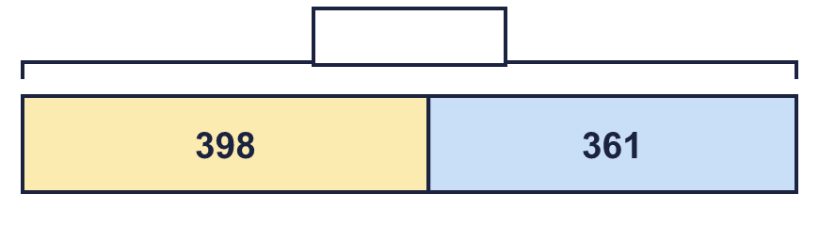
  1 | Look at the bar model. Add the parts to find the whole.
  2 | Look at the bar model. Subtract to find the missing part.  
  2 | Look at the bar model. Subtract to find the missing part.
  3 | Look at the bar model. Add the parts to find the whole.  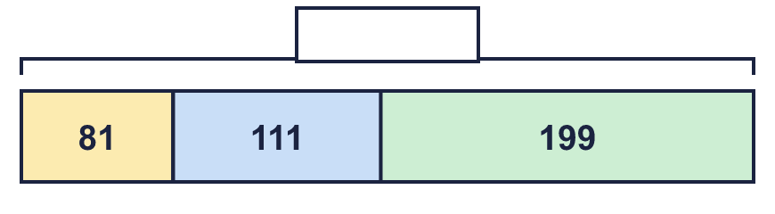
  3 | Look at the bar model. Add the parts to find the whole.
  4 | Tia has 153 cards, Filip has 177 cards and Zach has 165 cards.  a) How many cards do they have altogether?  b) How many more cards do Tia and Filip have together than Zach?
  4 | Tia has 153 cards, Filip has 177 cards and Zach has 165 cards.  a) How many cards do they have altogether?  b) How many more cards do Tia and Filip have together than Zach?
  5 | Leo has £876 in a bank account. Leo spends £29 on a kite.  How much money is left?
  5 | Leo has £876 in a bank account. Leo spends £29 on a kite.  How much money is left?
  6 | Nina has £350. Nina is given £95 more.  How much money does Nina have now?
  6 | Nina has £350. Nina is given £95 more.  How much money does Nina have now?
  7 | Kim collects 251 marbles. Mo collects 46 more marbles than Kim.  a) How many marbles does Mo collect?  b) How many marbles do they collect altogether?
  7 | Kim collects 251 marbles. Mo collects 46 more marbles than Kim.  a) How many marbles does Mo collect?  b) How many marbles do they collect altogether?
  8 | Sam has 287 pencils. Dora has 118 fewer pencils than Sam.  a) How many pencils does Dora have?  b) How many pencils do they have altogether?
  8 | Sam has 287 pencils. Dora has 118 fewer pencils than Sam.  a) How many pencils does Dora have?  b) How many pencils do they have altogether?

  9 | Amir has 125 balloons, Leo has 279 balloons and Mo has 109 balloons.  a) How many balloons do they have altogether?  b) How many more balloons do Amir and Leo have together than Mo?
  9 | Amir has 125 balloons, Leo has 279 balloons and Mo has 109 balloons.  a) How many balloons do they have altogether?  b) How many more balloons do Amir and Leo have together than Mo?
  10 | Look at the bar model. Subtract to find the missing part.  
  10 | Look at the bar model. Subtract to find the missing part.
  11 | Is Boba correct? Circle yes or no.  Yes / No  What is the correct answer?  Explain the mistake.
     | 
  11 | Is Boba correct? Circle yes or no.  Yes / No  What is the correct answer?  Explain the mistake.
  12 | What number did I think of?
    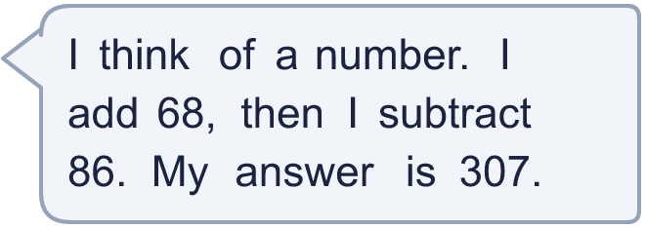
  12 | What number did I think of?
  13 | Write two different additions with an answer of exactly 300. Each has a 3-digit number and a 2-digit number.
  13 | Write two different additions with an answer of exactly 300. Each has a 3-digit number and a 2-digit number.
  14 | Tom uses an addition to check a subtraction. Is the subtraction correct? Circle yes or no.  525 − 242 = 283  Yes / No  Explain how you know.
  14 | Tom uses an addition to check a subtraction. Is the subtraction correct? Circle yes or no.  525 − 242 = 283  Yes / No  Explain how you know.

Year 3 · Addition and subtraction · Step 22
Make decisions
Answers (teacher copy)

  1 | Look at the bar model. Add the parts to find the whole.  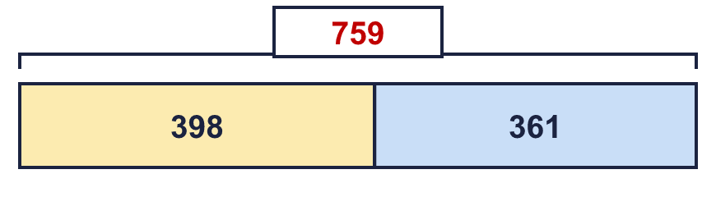  The whole is 759
  2 | Look at the bar model. Subtract to find the missing part.  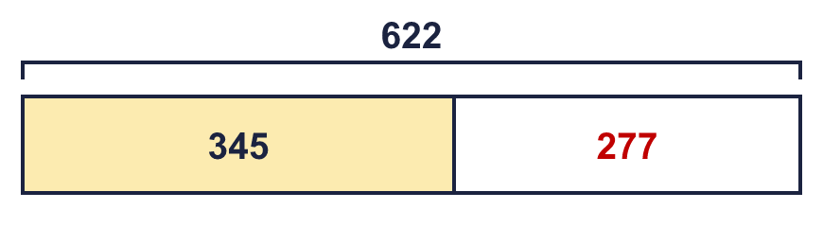  The missing part is 277
  3 | Look at the bar model. Add the parts to find the whole.  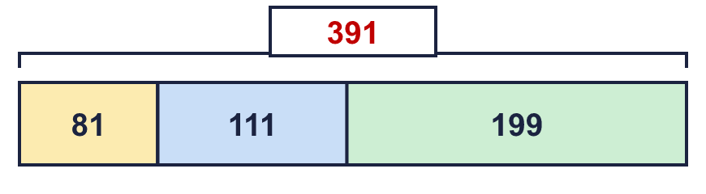  The whole is 391
  4 | Tia has 153 cards, Filip has 177 cards and Zach has 165 cards.  a) How many cards do they have altogether? 495  b) How many more cards do Tia and Filip have together than Zach? 165
  5 | Leo has £876 in a bank account. Leo spends £29 on a kite.  How much money is left? £847
  6 | Nina has £350. Nina is given £95 more.  How much money does Nina have now? £445
  7 | Kim collects 251 marbles. Mo collects 46 more marbles than Kim.  a) How many marbles does Mo collect? 297  b) How many marbles do they collect altogether? 548
  8 | Sam has 287 pencils. Dora has 118 fewer pencils than Sam.  a) How many pencils does Dora have? 169  b) How many pencils do they have altogether? 456
  9 | Amir has 125 balloons, Leo has 279 balloons and Mo has 109 balloons.  a) How many balloons do they have altogether? 513  b) How many more balloons do Amir and Leo have together than Mo? 295
  10 | Look at the bar model. Subtract to find the missing part.  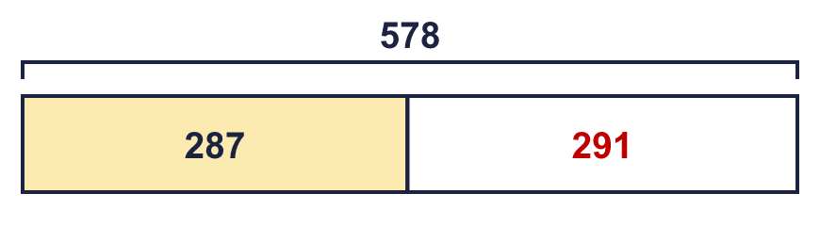  The missing part is 291
  11 | Is Boba correct? Circle yes or no.  Yes / No  What is the correct answer? 493  Explain the mistake.  568 − 75 = 493. The answer 593 is too big by 100.
  12 | What number did I think of? 325
  13 | Write two different additions with an answer of exactly 300. Each has a 3-digit number and a 2-digit number.  for example 278 + 22 and 246 + 54
  14 | Tom uses an addition to check a subtraction. Is the subtraction correct? Circle yes or no.  525 − 242 = 283  Yes / No  Explain how you know.  283 + 242 = 525, so 525 − 242 = 283.

