  Year 3 · Addition and subtraction · Step 20  Estimate answers | 
  Year 3 · Addition and subtraction · Step 20
  Estimate answers
  1 | Round each number to the nearest 10 to estimate the answers.  a) 197 + 256 (nearest 10) ≈  b) 292 + 323 (nearest 10) ≈  c) 260 + 357 (nearest 10) ≈
  1 | Round each number to the nearest 10 to estimate the answers.  a) 197 + 256 (nearest 10) ≈  b) 292 + 323 (nearest 10) ≈  c) 260 + 357 (nearest 10) ≈
  2 | Round each number to the nearest 100 to estimate the answers.  a) 835 + 89 (nearest 100) ≈  b) 201 + 173 (nearest 100) ≈  c) 590 + 78 (nearest 100) ≈
  2 | Round each number to the nearest 100 to estimate the answers.  a) 835 + 89 (nearest 100) ≈  b) 201 + 173 (nearest 100) ≈  c) 590 + 78 (nearest 100) ≈
  3 | Round each number to the nearest 10 to estimate the answers.  a) 642 − 198 (nearest 10) ≈  b) 194 − 173 (nearest 10) ≈  c) 646 − 116 (nearest 10) ≈
  3 | Round each number to the nearest 10 to estimate the answers.  a) 642 − 198 (nearest 10) ≈  b) 194 − 173 (nearest 10) ≈  c) 646 − 116 (nearest 10) ≈
  4 | Round each number to the nearest 100 to estimate the answers.  a) 484 − 371 (nearest 100) ≈  b) 144 − 131 (nearest 100) ≈  c) 558 − 43 (nearest 100) ≈
  4 | Round each number to the nearest 100 to estimate the answers.  a) 484 − 371 (nearest 100) ≈  b) 144 − 131 (nearest 100) ≈  c) 558 − 43 (nearest 100) ≈
  5 | 562 + 107. Round each number to the nearest 10 to estimate the answer. Then work out the actual answer.  Estimate:  Actual answer:
  5 | 562 + 107. Round each number to the nearest 10 to estimate the answer. Then work out the actual answer.  Estimate:  Actual answer:
  6 | 224 + 160. Round each number to the nearest 100 to estimate the answer. Then work out the actual answer.  Estimate:  Actual answer:
  6 | 224 + 160. Round each number to the nearest 100 to estimate the answer. Then work out the actual answer.  Estimate:  Actual answer:
  7 | 879 − 347. Round each number to the nearest 10 to estimate the answer. Then work out the actual answer.  Estimate:  Actual answer:
  7 | 879 − 347. Round each number to the nearest 10 to estimate the answer. Then work out the actual answer.  Estimate:  Actual answer:
  8 | 527 − 338. Round each number to the nearest 100 to estimate the answer. Then work out the actual answer.  Estimate:  Actual answer:
  8 | 527 − 338. Round each number to the nearest 100 to estimate the answer. Then work out the actual answer.  Estimate:  Actual answer:

  9 | Is each calculation correct? Circle yes or no.  a) 809 + 26 = 835  Yes / No  b) 147 + 69 = 216  Yes / No  c) 310 − 64 = 245  Yes / No
  9 | Is each calculation correct? Circle yes or no.  a) 809 + 26 = 835  Yes / No  b) 147 + 69 = 216  Yes / No  c) 310 − 64 = 245  Yes / No
  10 | Is Boba correct? Circle yes or no.  Yes / No  What is the correct answer?  Explain the mistake.
     | 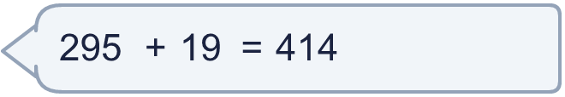
  10 | Is Boba correct? Circle yes or no.  Yes / No  What is the correct answer?  Explain the mistake.
  11 | What number did I think of?
    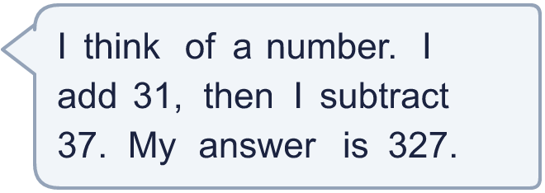
  11 | What number did I think of?
  12 | Write two different additions with an answer of exactly 700. Each has a 3-digit number and a 2-digit number.
  12 | Write two different additions with an answer of exactly 700. Each has a 3-digit number and a 2-digit number.
  13 | Ron collects 163 shells. Alex collects 121 more shells than Ron.  a) How many shells does Alex collect?  b) How many shells do they collect altogether?
  13 | Ron collects 163 shells. Alex collects 121 more shells than Ron.  a) How many shells does Alex collect?  b) How many shells do they collect altogether?
  14 | Mo uses an addition to check a subtraction. Is the subtraction correct? Circle yes or no.  510 − 177 = 333  Yes / No  Explain how you know.
  14 | Mo uses an addition to check a subtraction. Is the subtraction correct? Circle yes or no.  510 − 177 = 333  Yes / No  Explain how you know.

Year 3 · Addition and subtraction · Step 20
Estimate answers
Answers (teacher copy)

  1 | Round each number to the nearest 10 to estimate the answers.  a) 197 + 256 (nearest 10) ≈ 460  b) 292 + 323 (nearest 10) ≈ 610  c) 260 + 357 (nearest 10) ≈ 620
  2 | Round each number to the nearest 100 to estimate the answers.  a) 835 + 89 (nearest 100) ≈ 900  b) 201 + 173 (nearest 100) ≈ 400  c) 590 + 78 (nearest 100) ≈ 700
  3 | Round each number to the nearest 10 to estimate the answers.  a) 642 − 198 (nearest 10) ≈ 440  b) 194 − 173 (nearest 10) ≈ 20  c) 646 − 116 (nearest 10) ≈ 530
  4 | Round each number to the nearest 100 to estimate the answers.  a) 484 − 371 (nearest 100) ≈ 100  b) 144 − 131 (nearest 100) ≈ 0  c) 558 − 43 (nearest 100) ≈ 600
  5 | 562 + 107. Round each number to the nearest 10 to estimate the answer. Then work out the actual answer.  Estimate: 670  Actual answer: 669
  6 | 224 + 160. Round each number to the nearest 100 to estimate the answer. Then work out the actual answer.  Estimate: 400  Actual answer: 384
  7 | 879 − 347. Round each number to the nearest 10 to estimate the answer. Then work out the actual answer.  Estimate: 530  Actual answer: 532
  8 | 527 − 338. Round each number to the nearest 100 to estimate the answer. Then work out the actual answer.  Estimate: 200  Actual answer: 189
  9 | Is each calculation correct? Circle yes or no.  a) 809 + 26 = 835  Yes / No  b) 147 + 69 = 216  Yes / No  c) 310 − 64 = 245  Yes / No
  10 | Is Boba correct? Circle yes or no.  Yes / No  What is the correct answer? 314  Explain the mistake.  295 + 19 = 314. The answer 414 is too big by 100.
  11 | What number did I think of? 333
  12 | Write two different additions with an answer of exactly 700. Each has a 3-digit number and a 2-digit number.  for example 678 + 22 and 646 + 54
  13 | Ron collects 163 shells. Alex collects 121 more shells than Ron.  a) How many shells does Alex collect? 284  b) How many shells do they collect altogether? 447
  14 | Mo uses an addition to check a subtraction. Is the subtraction correct? Circle yes or no.  510 − 177 = 333  Yes / No  Explain how you know.  333 + 177 = 510, so 510 − 177 = 333.

