  Year 3 · Addition and subtraction · Step 19  Complements to 100 | 
  Year 3 · Addition and subtraction · Step 19
  Complements to 100
  1 | Find the complement to 100: the number that makes 100.
    a) | 96 + |  | = 100
    b) | 72 + |  | = 100
    c) | 61 + |  | = 100
  1 | Find the complement to 100: the number that makes 100.
    a) | 96 + |  | = 100
    b) | 72 + |  | = 100
    c) | 61 + |  | = 100
  2 | Write the missing number to make 100.
    a) | 20 + |  | = 100
    b) | 90 + |  | = 100
    c) | 10 + |  | = 100
  2 | Write the missing number to make 100.
    a) | 20 + |  | = 100
    b) | 90 + |  | = 100
    c) | 10 + |  | = 100
  3 | Find the complement to 100: the number that makes 100.
    a) | 96 + |  | = 100
    b) | 68 + |  | = 100
    c) | 55 + |  | = 100
  3 | Find the complement to 100: the number that makes 100.
    a) | 96 + |  | = 100
    b) | 68 + |  | = 100
    c) | 55 + |  | = 100
  4 | Write the missing number in each calculation.
    a) | 306 + |  | = 400
    b) | 682 + |  | = 700
    c) | 237 + |  | = 300
  4 | Write the missing number in each calculation.
    a) | 306 + |  | = 400
    b) | 682 + |  | = 700
    c) | 237 + |  | = 300
  5 | Nina has a box of 100 marbles. 29 of them are red.  How many marbles are not red?
  5 | Nina has a box of 100 marbles. 29 of them are red.  How many marbles are not red?
  6 | Find the complement to 100: the number that makes 100.
    a) | 45 + |  | = 100
    b) | 55 + |  | = 100
    c) | 88 + |  | = 100
  6 | Find the complement to 100: the number that makes 100.
    a) | 45 + |  | = 100
    b) | 55 + |  | = 100
    c) | 88 + |  | = 100
  7 | Write the missing number in each calculation.
    a) | 183 + |  | = 200
    b) | 842 + |  | = 900
    c) | 661 + |  | = 700
  7 | Write the missing number in each calculation.
    a) | 183 + |  | = 200
    b) | 842 + |  | = 900
    c) | 661 + |  | = 700
  8 | Sam has a box of 100 books. 87 of them are red.  How many books are not red?
  8 | Sam has a box of 100 books. 87 of them are red.  How many books are not red?

  9 | Is each calculation correct? Circle yes or no.  a) 864 + 67 = 941  Yes / No  b) 487 + 35 = 522  Yes / No  c) 329 + 54 = 383  Yes / No
  9 | Is each calculation correct? Circle yes or no.  a) 864 + 67 = 941  Yes / No  b) 487 + 35 = 522  Yes / No  c) 329 + 54 = 383  Yes / No
  10 | Is Boba correct? Circle yes or no.  Yes / No  What is the correct answer?  Explain the mistake.
     | 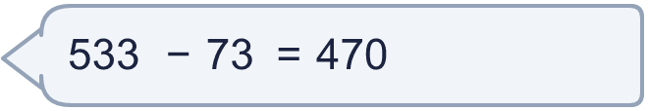
  10 | Is Boba correct? Circle yes or no.  Yes / No  What is the correct answer?  Explain the mistake.
  11 | What number did I think of?
    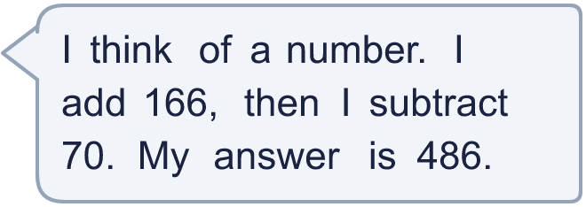
  11 | What number did I think of?
  12 | Write two different additions with an answer of exactly 100. Each has a 2-digit number and a 2-digit number.
  12 | Write two different additions with an answer of exactly 100. Each has a 2-digit number and a 2-digit number.
  13 | Nina has a box of 100 stamps. 38 of them are red.  How many stamps are not red?
  13 | Nina has a box of 100 stamps. 38 of them are red.  How many stamps are not red?
  14 | 705 − 494 = 211. Write the addition that checks it.  211 + 494 =
  14 | 705 − 494 = 211. Write the addition that checks it.  211 + 494 =

Year 3 · Addition and subtraction · Step 19
Complements to 100
Answers (teacher copy)

  1 | Find the complement to 100: the number that makes 100.  a) 96 + 4 = 100  b) 72 + 28 = 100  c) 61 + 39 = 100
  2 | Write the missing number to make 100.  a) 20 + 80 = 100  b) 90 + 10 = 100  c) 10 + 90 = 100
  3 | Find the complement to 100: the number that makes 100.  a) 96 + 4 = 100  b) 68 + 32 = 100  c) 55 + 45 = 100
  4 | Write the missing number in each calculation.  a) 306 + 94 = 400  b) 682 + 18 = 700  c) 237 + 63 = 300
  5 | Nina has a box of 100 marbles. 29 of them are red.  How many marbles are not red? 71
  6 | Find the complement to 100: the number that makes 100.  a) 45 + 55 = 100  b) 55 + 45 = 100  c) 88 + 12 = 100
  7 | Write the missing number in each calculation.  a) 183 + 17 = 200  b) 842 + 58 = 900  c) 661 + 39 = 700
  8 | Sam has a box of 100 books. 87 of them are red.  How many books are not red? 13
  9 | Is each calculation correct? Circle yes or no.  a) 864 + 67 = 941  Yes / No  b) 487 + 35 = 522  Yes / No  c) 329 + 54 = 383  Yes / No
  10 | Is Boba correct? Circle yes or no.  Yes / No  What is the correct answer? 460  Explain the mistake.  533 − 73 = 460. The answer 470 is too big by 10.
  11 | What number did I think of? 390
  12 | Write two different additions with an answer of exactly 100. Each has a 2-digit number and a 2-digit number.  for example 70 + 30 and 55 + 45
  13 | Nina has a box of 100 stamps. 38 of them are red.  How many stamps are not red? 62
  14 | 705 − 494 = 211. Write the addition that checks it.  211 + 494 = 705

