  Year 3 · Addition and subtraction · Step 1  Apply number bonds within 10 | 
  Year 3 · Addition and subtraction · Step 1
  Apply number bonds within 10
  1 | Complete the sentences.
    a) | 1 ones + 5 ones = |  | ones
    b) | 5 tens + 3 tens = |  | tens
    c) | 3 hundreds + 4 hundreds =
    hundreds
  1 | Complete the sentences.
    a) | 1 ones + 5 ones = |  | ones
    b) | 5 tens + 3 tens = |  | tens
    c) | 3 hundreds + 4 hundreds =
    hundreds
  2 | Use the first fact to help you complete the additions.  a) 6 + 1 =  b) 60 + 10 =  c) 600 + 100 =
  2 | Use the first fact to help you complete the additions.  a) 6 + 1 =  b) 60 + 10 =  c) 600 + 100 =
  3 | Use the first fact to help you complete the subtractions.  a) 6 − 3 =  b) 60 − 30 =  c) 600 − 300 =
  3 | Use the first fact to help you complete the subtractions.  a) 6 − 3 =  b) 60 − 30 =  c) 600 − 300 =
  4 | Write the missing number in each calculation.
    a) | 7 + |  | = 8
    b) | 70 + |  | = 80
    c) | 700 + |  | = 800
  4 | Write the missing number in each calculation.
    a) | 7 + |  | = 8
    b) | 70 + |  | = 80
    c) | 700 + |  | = 800
  5 | Complete the sentences.
    a) | 4 hundreds − 2 hundreds =
    hundreds
    b) | 9 ones − 1 ones = |  | ones
    c) | 5 tens − 1 tens = |  | tens
  5 | Complete the sentences.
    a) | 4 hundreds − 2 hundreds =
    hundreds
    b) | 9 ones − 1 ones = |  | ones
    c) | 5 tens − 1 tens = |  | tens
  6 | Work out the calculations.  a) 400 + 500 =  b) 40 − 10 =  c) 3 + 6 =  d) 5 − 2 =
  6 | Work out the calculations.  a) 400 + 500 =  b) 40 − 10 =  c) 3 + 6 =  d) 5 − 2 =
  7 | Mo has 70 stickers. A friend gives Mo 10 more.  a) How many stickers does Mo have now?  b) How many did Mo have to start with?
  7 | Mo has 70 stickers. A friend gives Mo 10 more.  a) How many stickers does Mo have now?  b) How many did Mo have to start with?
  8 | Write the missing number in each calculation.
    a) | 9 − |  | = 5
    b) | 90 − |  | = 50
    c) | 900 − |  | = 500
  8 | Write the missing number in each calculation.
    a) | 9 − |  | = 5
    b) | 90 − |  | = 50
    c) | 900 − |  | = 500

  9 | Is each calculation correct? Circle yes or no.  a) 50 + 10 = 70  Yes / No  b) 30 + 50 = 80  Yes / No  c) 60 + 10 = 70  Yes / No
  9 | Is each calculation correct? Circle yes or no.  a) 50 + 10 = 70  Yes / No  b) 30 + 50 = 80  Yes / No  c) 60 + 10 = 70  Yes / No
  10 | Is each calculation correct? Circle yes or no.  a) 400 + 300 = 700  Yes / No  b) 400 + 300 = 700  Yes / No  c) 30 + 40 = 80  Yes / No
  10 | Is each calculation correct? Circle yes or no.  a) 400 + 300 = 700  Yes / No  b) 400 + 300 = 700  Yes / No  c) 30 + 40 = 80  Yes / No
  11 | What number did I think of?
    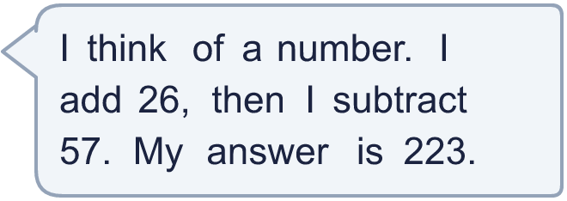
  11 | What number did I think of?
  12 | Write two different additions with an answer of exactly 90. Each has a 2-digit number and a 2-digit number.
  12 | Write two different additions with an answer of exactly 90. Each has a 2-digit number and a 2-digit number.
  13 | Kim has 400 beads. A friend gives Kim 300 more.  a) How many beads does Kim have now?  b) How many did Kim have to start with?
  13 | Kim has 400 beads. A friend gives Kim 300 more.  a) How many beads does Kim have now?  b) How many did Kim have to start with?
  14 | Is Boba correct? Circle yes or no.  Yes / No  What is the correct answer?  Explain the mistake.
     | 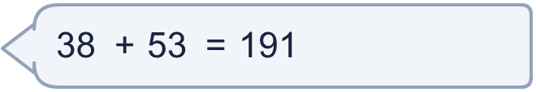
  14 | Is Boba correct? Circle yes or no.  Yes / No  What is the correct answer?  Explain the mistake.

Year 3 · Addition and subtraction · Step 1
Apply number bonds within 10
Answers (teacher copy)

  1 | Complete the sentences.  a) 1 ones + 5 ones = 6 ones  b) 5 tens + 3 tens = 8 tens  c) 3 hundreds + 4 hundreds = 7 hundreds
  2 | Use the first fact to help you complete the additions.  a) 6 + 1 = 7  b) 60 + 10 = 70  c) 600 + 100 = 700
  3 | Use the first fact to help you complete the subtractions.  a) 6 − 3 = 3  b) 60 − 30 = 30  c) 600 − 300 = 300
  4 | Write the missing number in each calculation.  a) 7 + 1 = 8  b) 70 + 10 = 80  c) 700 + 100 = 800
  5 | Complete the sentences.  a) 4 hundreds − 2 hundreds = 2 hundreds  b) 9 ones − 1 ones = 8 ones  c) 5 tens − 1 tens = 4 tens
  6 | Work out the calculations.  a) 400 + 500 = 900  b) 40 − 10 = 30  c) 3 + 6 = 9  d) 5 − 2 = 3
  7 | Mo has 70 stickers. A friend gives Mo 10 more.  a) How many stickers does Mo have now? 80  b) How many did Mo have to start with? 70
  8 | Write the missing number in each calculation.  a) 9 − 4 = 5  b) 90 − 40 = 50  c) 900 − 400 = 500
  9 | Is each calculation correct? Circle yes or no.  a) 50 + 10 = 70  Yes / No  b) 30 + 50 = 80  Yes / No  c) 60 + 10 = 70  Yes / No
  10 | Is each calculation correct? Circle yes or no.  a) 400 + 300 = 700  Yes / No  b) 400 + 300 = 700  Yes / No  c) 30 + 40 = 80  Yes / No
  11 | What number did I think of? 254
  12 | Write two different additions with an answer of exactly 90. Each has a 2-digit number and a 2-digit number.  for example 68 + 22 and 36 + 54
  13 | Kim has 400 beads. A friend gives Kim 300 more.  a) How many beads does Kim have now? 700  b) How many did Kim have to start with? 400
  14 | Is Boba correct? Circle yes or no.  Yes / No  What is the correct answer? 91  Explain the mistake.  38 + 53 = 91. The answer 191 is too big by 100.

