  Year 3 · Addition and subtraction · Step 11  Add two numbers with no exchange | 
  Year 3 · Addition and subtraction · Step 11
  Add two numbers with no exchange
  1 | Complete the column addition. Write the missing digits in the answer.  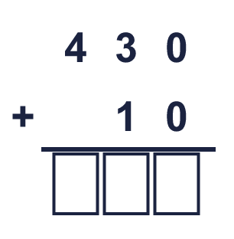
  1 | Complete the column addition. Write the missing digits in the answer.
  2 | Work out the additions.  a) 15 + 44 =  b) 13 + 81 =  c) 41 + 53 =
  2 | Work out the additions.  a) 15 + 44 =  b) 13 + 81 =  c) 41 + 53 =
  3 | Work out the additions.  a) 220 + 264 =  b) 110 + 612 =  c) 353 + 345 =
  3 | Work out the additions.  a) 220 + 264 =  b) 110 + 612 =  c) 353 + 345 =
  4 | Complete the column addition. Write the missing digits in the answer.  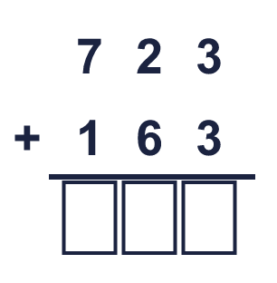
  4 | Complete the column addition. Write the missing digits in the answer.
  5 | Write the missing digits in the calculation.  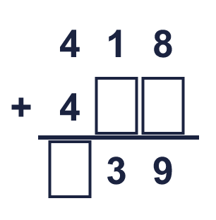
  5 | Write the missing digits in the calculation.
  6 | Work out the calculations. Write the units in your answer.  a) £524 + £165 =  b) 563 ml + 320 ml =  c) 222 kg + 656 kg =
  6 | Work out the calculations. Write the units in your answer.  a) £524 + £165 =  b) 563 ml + 320 ml =  c) 222 kg + 656 kg =
  7 | Kim has 234 balloons. Ron has 335 balloons.  a) How many balloons do they have altogether?  b) Ron has how many more balloons than Kim?
  7 | Kim has 234 balloons. Ron has 335 balloons.  a) How many balloons do they have altogether?  b) Ron has how many more balloons than Kim?
  8 | Look at the bar model. Add the parts to find the whole.  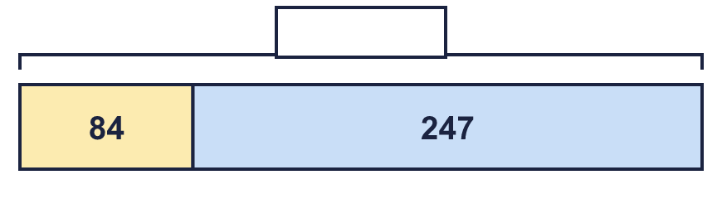
  8 | Look at the bar model. Add the parts to find the whole.

  9 | Is each calculation correct? Circle yes or no.  a) 762 − 58 = 704  Yes / No  b) 676 + 95 = 770  Yes / No  c) 525 − 29 = 486  Yes / No
  9 | Is each calculation correct? Circle yes or no.  a) 762 − 58 = 704  Yes / No  b) 676 + 95 = 770  Yes / No  c) 525 − 29 = 486  Yes / No
  10 | Is Boba correct? Circle yes or no.  Yes / No  What is the correct answer?  Explain the mistake.
     | 
  10 | Is Boba correct? Circle yes or no.  Yes / No  What is the correct answer?  Explain the mistake.
  11 | What number did I think of?
    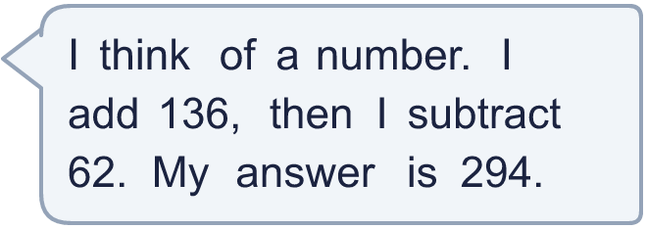
  11 | What number did I think of?
  12 | Write two different additions with an answer of exactly 400. Each has a 3-digit number and a 2-digit number.
  12 | Write two different additions with an answer of exactly 400. Each has a 3-digit number and a 2-digit number.
  13 | Nina collects 257 shells. Zach collects 176 more shells than Nina.  a) How many shells does Zach collect?  b) How many shells do they collect altogether?
  13 | Nina collects 257 shells. Zach collects 176 more shells than Nina.  a) How many shells does Zach collect?  b) How many shells do they collect altogether?
  14 | Look at the bar model. Add the parts to find the whole.  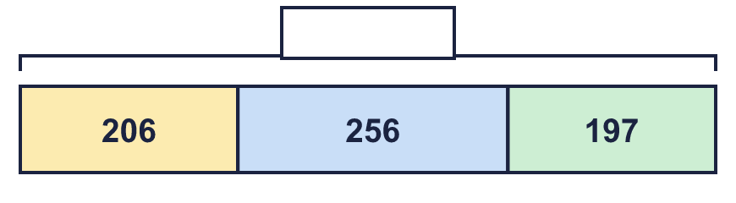
  14 | Look at the bar model. Add the parts to find the whole.

Year 3 · Addition and subtraction · Step 11
Add two numbers with no exchange
Answers (teacher copy)

  1 | Complete the column addition. Write the missing digits in the answer.  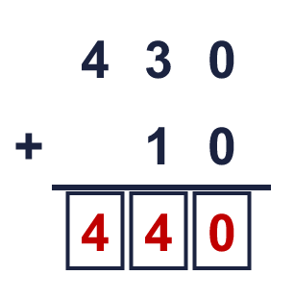  Answer: 440
  2 | Work out the additions.  a) 15 + 44 = 59  b) 13 + 81 = 94  c) 41 + 53 = 94
  3 | Work out the additions.  a) 220 + 264 = 484  b) 110 + 612 = 722  c) 353 + 345 = 698
  4 | Complete the column addition. Write the missing digits in the answer.  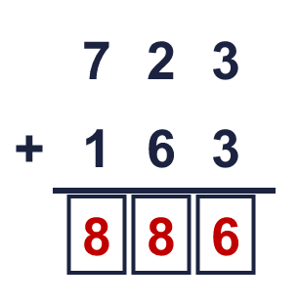  Answer: 886
  5 | Write the missing digits in the calculation.  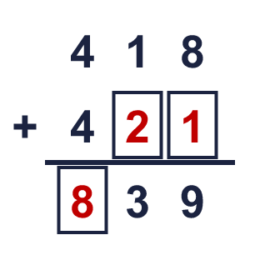  Missing digits, from top to bottom and left to right: 2 1 8
  6 | Work out the calculations. Write the units in your answer.  a) £524 + £165 = £689  b) 563 ml + 320 ml = 883 ml  c) 222 kg + 656 kg = 878 kg
  7 | Kim has 234 balloons. Ron has 335 balloons.  a) How many balloons do they have altogether? 569  b) Ron has how many more balloons than Kim? 101
  8 | Look at the bar model. Add the parts to find the whole.  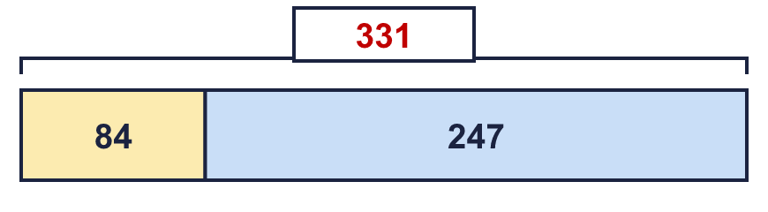  The whole is 331
  9 | Is each calculation correct? Circle yes or no.  a) 762 − 58 = 704  Yes / No  b) 676 + 95 = 770  Yes / No  c) 525 − 29 = 486  Yes / No
  10 | Is Boba correct? Circle yes or no.  Yes / No  What is the correct answer? 394  Explain the mistake.  351 + 43 = 394. The answer 294 is too small by 100.
  11 | What number did I think of? 220
  12 | Write two different additions with an answer of exactly 400. Each has a 3-digit number and a 2-digit number.  for example 378 + 22 and 346 + 54
  13 | Nina collects 257 shells. Zach collects 176 more shells than Nina.  a) How many shells does Zach collect? 433  b) How many shells do they collect altogether? 690
  14 | Look at the bar model. Add the parts to find the whole.  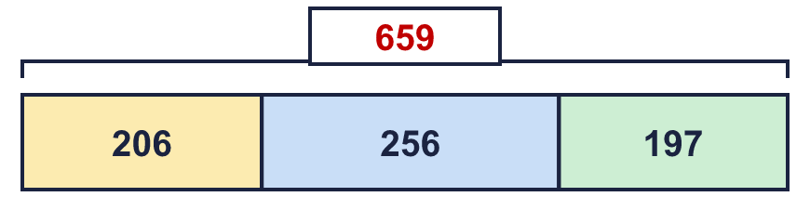  The whole is 659

