  Year 3 · Addition and subtraction · Step 14  Add two numbers across a 100 | 
  Year 3 · Addition and subtraction · Step 14
  Add two numbers across a 100
  1 | Complete the column addition. Write the missing digits in the answer.  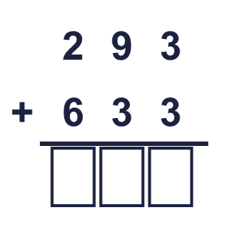
  1 | Complete the column addition. Write the missing digits in the answer.
  2 | Work out the additions.  a) 424 + 495 =  b) 184 + 662 =  c) 191 + 714 =
  2 | Work out the additions.  a) 424 + 495 =  b) 184 + 662 =  c) 191 + 714 =
  3 | Work out the additions.  a) 691 + 73 =  b) 444 + 65 =  c) 682 + 41 =
  3 | Work out the additions.  a) 691 + 73 =  b) 444 + 65 =  c) 682 + 41 =
  4 | Complete the column addition. Write the missing digits in the answer.  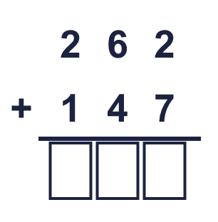
  4 | Complete the column addition. Write the missing digits in the answer.
  5 | Write the missing digits in the calculation.  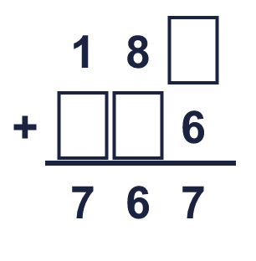
  5 | Write the missing digits in the calculation.
  6 | Work out the calculations. Write the units in your answer.  a) 281 m + 384 m =  b) 658 ml + 191 ml =  c) 578 kg + 131 kg =
  6 | Work out the calculations. Write the units in your answer.  a) 281 m + 384 m =  b) 658 ml + 191 ml =  c) 578 kg + 131 kg =
  7 | Jo has 216 marbles. Kim has 291 marbles.  a) How many marbles do they have altogether?  b) Kim has how many more marbles than Jo?
  7 | Jo has 216 marbles. Kim has 291 marbles.  a) How many marbles do they have altogether?  b) Kim has how many more marbles than Jo?
  8 | Look at the bar model. Add the parts to find the whole.  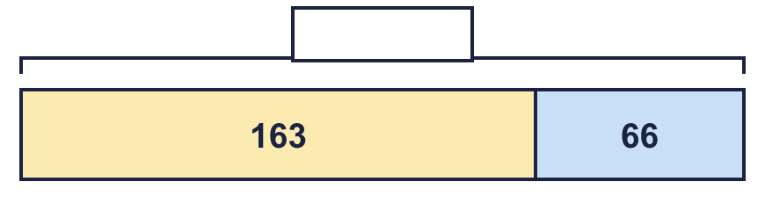
  8 | Look at the bar model. Add the parts to find the whole.

  9 | Is each calculation correct? Circle yes or no.  a) 817 + 37 = 864  Yes / No  b) 360 + 49 = 410  Yes / No  c) 218 − 64 = 154  Yes / No
  9 | Is each calculation correct? Circle yes or no.  a) 817 + 37 = 864  Yes / No  b) 360 + 49 = 410  Yes / No  c) 218 − 64 = 154  Yes / No
  10 | Is Boba correct? Circle yes or no.  Yes / No  What is the correct answer?  Explain the mistake.
     | 
  10 | Is Boba correct? Circle yes or no.  Yes / No  What is the correct answer?  Explain the mistake.
  11 | What number did I think of?
    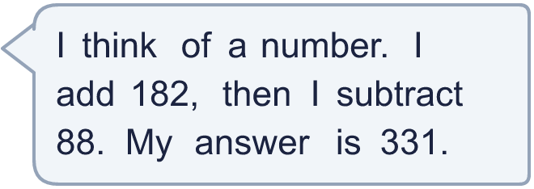
  11 | What number did I think of?
  12 | Write two different additions with an answer of exactly 700. Each has a 3-digit number and a 2-digit number.
  12 | Write two different additions with an answer of exactly 700. Each has a 3-digit number and a 2-digit number.
  13 | Sam collects 137 coins. Jo collects 118 more coins than Sam.  a) How many coins does Jo collect?  b) How many coins do they collect altogether?
  13 | Sam collects 137 coins. Jo collects 118 more coins than Sam.  a) How many coins does Jo collect?  b) How many coins do they collect altogether?
  14 | Leo uses an addition to check a subtraction. Is the subtraction correct? Circle yes or no.  857 − 611 = 246  Yes / No  Explain how you know.
  14 | Leo uses an addition to check a subtraction. Is the subtraction correct? Circle yes or no.  857 − 611 = 246  Yes / No  Explain how you know.

Year 3 · Addition and subtraction · Step 14
Add two numbers across a 100
Answers (teacher copy)

  1 | Complete the column addition. Write the missing digits in the answer.  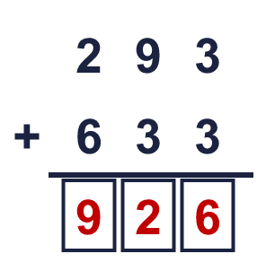  Answer: 926
  2 | Work out the additions.  a) 424 + 495 = 919  b) 184 + 662 = 846  c) 191 + 714 = 905
  3 | Work out the additions.  a) 691 + 73 = 764  b) 444 + 65 = 509  c) 682 + 41 = 723
  4 | Complete the column addition. Write the missing digits in the answer.  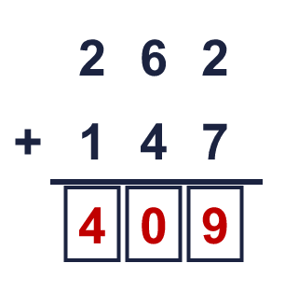  Answer: 409
  5 | Write the missing digits in the calculation.  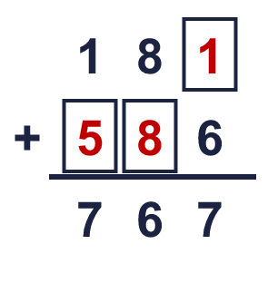  Missing digits, from top to bottom and left to right: 1 5 8
  6 | Work out the calculations. Write the units in your answer.  a) 281 m + 384 m = 665 m  b) 658 ml + 191 ml = 849 ml  c) 578 kg + 131 kg = 709 kg
  7 | Jo has 216 marbles. Kim has 291 marbles.  a) How many marbles do they have altogether? 507  b) Kim has how many more marbles than Jo? 75
  8 | Look at the bar model. Add the parts to find the whole.  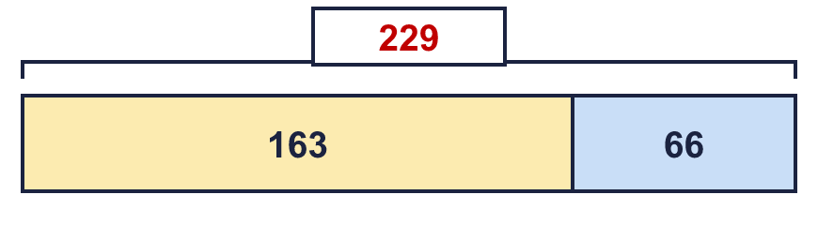  The whole is 229
  9 | Is each calculation correct? Circle yes or no.  a) 817 + 37 = 864  Yes / No  b) 360 + 49 = 410  Yes / No  c) 218 − 64 = 154  Yes / No
  10 | Is Boba correct? Circle yes or no.  Yes / No  What is the correct answer? 768  Explain the mistake.  694 + 74 = 768. The answer 758 is too small by 10.
  11 | What number did I think of? 237
  12 | Write two different additions with an answer of exactly 700. Each has a 3-digit number and a 2-digit number.  for example 678 + 22 and 646 + 54
  13 | Sam collects 137 coins. Jo collects 118 more coins than Sam.  a) How many coins does Jo collect? 255  b) How many coins do they collect altogether? 392
  14 | Leo uses an addition to check a subtraction. Is the subtraction correct? Circle yes or no.  857 − 611 = 246  Yes / No  Explain how you know.  246 + 611 = 857, so 857 − 611 = 246.

