  Year 3 · Addition and subtraction · Step 13  Add two numbers across a 10 | 
  Year 3 · Addition and subtraction · Step 13
  Add two numbers across a 10
  1 | Complete the column addition. Write the missing digits in the answer.  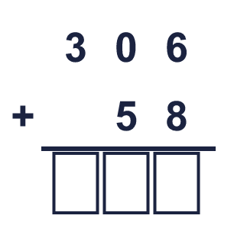
  1 | Complete the column addition. Write the missing digits in the answer.
  2 | Work out the additions.  a) 43 + 28 =  b) 34 + 17 =  c) 59 + 21 =
  2 | Work out the additions.  a) 43 + 28 =  b) 34 + 17 =  c) 59 + 21 =
  3 | Work out the additions.  a) 311 + 169 =  b) 227 + 245 =  c) 508 + 242 =
  3 | Work out the additions.  a) 311 + 169 =  b) 227 + 245 =  c) 508 + 242 =
  4 | Complete the column addition. Write the missing digits in the answer.  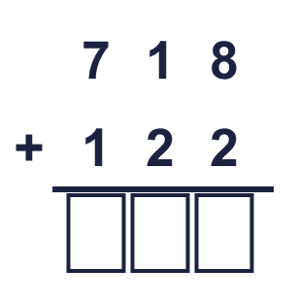
  4 | Complete the column addition. Write the missing digits in the answer.
  5 | Write the missing digits in the calculation.  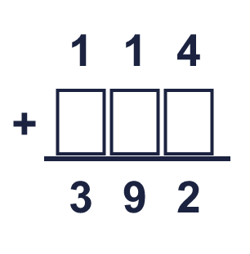
  5 | Write the missing digits in the calculation.
  6 | Work out the calculations. Write the units in your answer.  a) 184 ml + 109 ml =  b) £309 + £216 =  c) 518 kg + 173 kg =
  6 | Work out the calculations. Write the units in your answer.  a) 184 ml + 109 ml =  b) £309 + £216 =  c) 518 kg + 173 kg =
  7 | Tia has 358 coins. Zach has 306 coins.  a) How many coins do they have altogether?  b) Tia has how many more coins than Zach?
  7 | Tia has 358 coins. Zach has 306 coins.  a) How many coins do they have altogether?  b) Tia has how many more coins than Zach?
  8 | Look at the bar model. Add the parts to find the whole.  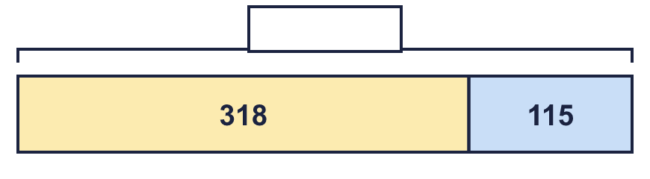
  8 | Look at the bar model. Add the parts to find the whole.

  9 | Is each calculation correct? Circle yes or no.  a) 996 − 59 = 938  Yes / No  b) 223 − 30 = 193  Yes / No  c) 459 + 63 = 522  Yes / No
  9 | Is each calculation correct? Circle yes or no.  a) 996 − 59 = 938  Yes / No  b) 223 − 30 = 193  Yes / No  c) 459 + 63 = 522  Yes / No
  10 | Is Boba correct? Circle yes or no.  Yes / No  What is the correct answer?  Explain the mistake.
     | 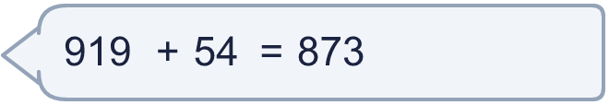
  10 | Is Boba correct? Circle yes or no.  Yes / No  What is the correct answer?  Explain the mistake.
  11 | What number did I think of?
    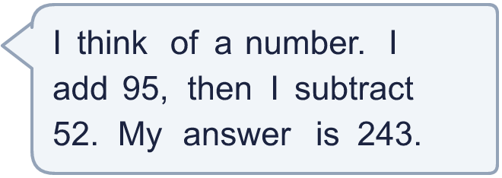
  11 | What number did I think of?
  12 | Write two different additions with an answer of exactly 700. Each has a 3-digit number and a 2-digit number.
  12 | Write two different additions with an answer of exactly 700. Each has a 3-digit number and a 2-digit number.
  13 | Zach collects 343 marbles. Jo collects 39 more marbles than Zach.  a) How many marbles does Jo collect?  b) How many marbles do they collect altogether?
  13 | Zach collects 343 marbles. Jo collects 39 more marbles than Zach.  a) How many marbles does Jo collect?  b) How many marbles do they collect altogether?
  14 | Ron uses an addition to check a subtraction. Is the subtraction correct? Circle yes or no.  662 − 150 = 412  Yes / No  Explain how you know.
  14 | Ron uses an addition to check a subtraction. Is the subtraction correct? Circle yes or no.  662 − 150 = 412  Yes / No  Explain how you know.

Year 3 · Addition and subtraction · Step 13
Add two numbers across a 10
Answers (teacher copy)

  1 | Complete the column addition. Write the missing digits in the answer.  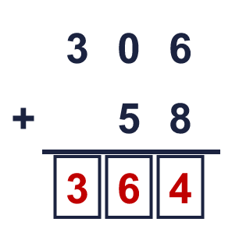  Answer: 364
  2 | Work out the additions.  a) 43 + 28 = 71  b) 34 + 17 = 51  c) 59 + 21 = 80
  3 | Work out the additions.  a) 311 + 169 = 480  b) 227 + 245 = 472  c) 508 + 242 = 750
  4 | Complete the column addition. Write the missing digits in the answer.  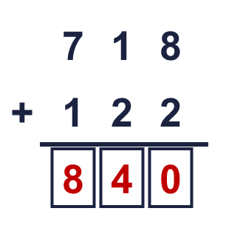  Answer: 840
  5 | Write the missing digits in the calculation.  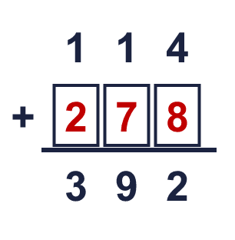  Missing digits, from top to bottom and left to right: 2 7 8
  6 | Work out the calculations. Write the units in your answer.  a) 184 ml + 109 ml = 293 ml  b) £309 + £216 = £525  c) 518 kg + 173 kg = 691 kg
  7 | Tia has 358 coins. Zach has 306 coins.  a) How many coins do they have altogether? 664  b) Tia has how many more coins than Zach? 52
  8 | Look at the bar model. Add the parts to find the whole.  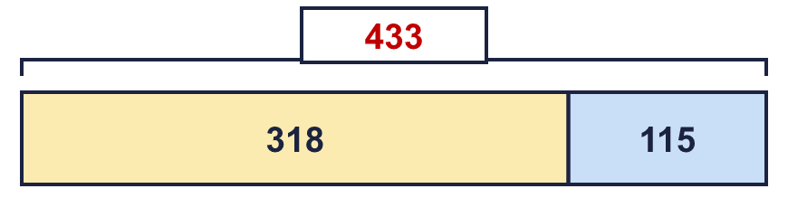  The whole is 433
  9 | Is each calculation correct? Circle yes or no.  a) 996 − 59 = 938  Yes / No  b) 223 − 30 = 193  Yes / No  c) 459 + 63 = 522  Yes / No
  10 | Is Boba correct? Circle yes or no.  Yes / No  What is the correct answer? 973  Explain the mistake.  919 + 54 = 973. The answer 873 is too small by 100.
  11 | What number did I think of? 200
  12 | Write two different additions with an answer of exactly 700. Each has a 3-digit number and a 2-digit number.  for example 678 + 22 and 646 + 54
  13 | Zach collects 343 marbles. Jo collects 39 more marbles than Zach.  a) How many marbles does Jo collect? 382  b) How many marbles do they collect altogether? 725
  14 | Ron uses an addition to check a subtraction. Is the subtraction correct? Circle yes or no.  662 − 150 = 412  Yes / No  Explain how you know.  512 + 150 = 662, so 662 − 150 = 512.

