  Year 3 · Addition and subtraction · Step 3  Add and subtract 10s | 
  Year 3 · Addition and subtraction · Step 3
  Add and subtract 10s
  1 | Work out the calculations.  a) 451 + 30 =  b) 511 + 30 =  c) 806 + 50 =
  1 | Work out the calculations.  a) 451 + 30 =  b) 511 + 30 =  c) 806 + 50 =
  2 | Work out the calculations.  a) 951 − 40 =  b) 969 − 60 =  c) 599 − 70 =
  2 | Work out the calculations.  a) 951 − 40 =  b) 969 − 60 =  c) 599 − 70 =
  3 | Count on in 10s. Write the missing numbers.
    104, |  | , |  | , |  | , | 144, | 154
  3 | Count on in 10s. Write the missing numbers.
    104, |  | , |  | , |  | , | 144, | 154
  4 | Count back in 10s. Write the missing numbers.
    452, |  | , |  | , | 422, |  | , | 402
  4 | Count back in 10s. Write the missing numbers.
    452, |  | , |  | , | 422, |  | , | 402
  5 | Work out the calculations.  a) 207 + 50 =  b) 927 + 20 =  c) 183 − 70 =  d) 883 − 80 =
  5 | Work out the calculations.  a) 207 + 50 =  b) 927 + 20 =  c) 183 − 70 =  d) 883 − 80 =
  6 | Tom has 100 coins. A friend gives Tom 200 more.  a) How many coins does Tom have now?  b) How many did Tom have to start with?
  6 | Tom has 100 coins. A friend gives Tom 200 more.  a) How many coins does Tom have now?  b) How many did Tom have to start with?
  7 | Work out the calculations.  a) 915 + 70 =  b) 857 + 20 =  c) 776 + 10 =  d) 411 + 80 =
  7 | Work out the calculations.  a) 915 + 70 =  b) 857 + 20 =  c) 776 + 10 =  d) 411 + 80 =
  8 | Work out the calculations.  a) 433 + 50 =  b) 616 + 50 =  c) 455 − 40 =  d) 599 − 80 =
  8 | Work out the calculations.  a) 433 + 50 =  b) 616 + 50 =  c) 455 − 40 =  d) 599 − 80 =

  9 | Is each calculation correct? Circle yes or no.  a) 614 − 71 = 543  Yes / No  b) 691 + 78 = 770  Yes / No  c) 707 + 97 = 804  Yes / No
  9 | Is each calculation correct? Circle yes or no.  a) 614 − 71 = 543  Yes / No  b) 691 + 78 = 770  Yes / No  c) 707 + 97 = 804  Yes / No
  10 | Is Boba correct? Circle yes or no.  Yes / No  What is the correct answer?  Explain the mistake.
     | 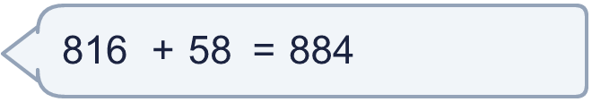
  10 | Is Boba correct? Circle yes or no.  Yes / No  What is the correct answer?  Explain the mistake.
  11 | What number did I think of?
    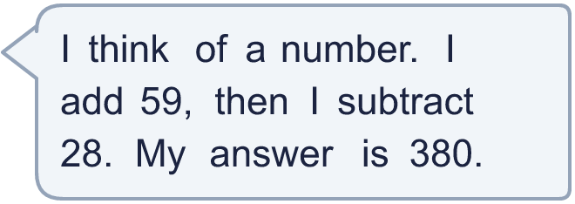
  11 | What number did I think of?
  12 | Write two different additions with an answer of exactly 400. Each has a 3-digit number and a 2-digit number.
  12 | Write two different additions with an answer of exactly 400. Each has a 3-digit number and a 2-digit number.
  13 | Zach collects 220 beads. Jo collects 83 more beads than Zach.  a) How many beads does Jo collect?  b) How many beads do they collect altogether?
  13 | Zach collects 220 beads. Jo collects 83 more beads than Zach.  a) How many beads does Jo collect?  b) How many beads do they collect altogether?
  14 | Rosie uses an addition to check a subtraction. Is the subtraction correct? Circle yes or no.  622 − 197 = 425  Yes / No  Explain how you know.
  14 | Rosie uses an addition to check a subtraction. Is the subtraction correct? Circle yes or no.  622 − 197 = 425  Yes / No  Explain how you know.

Year 3 · Addition and subtraction · Step 3
Add and subtract 10s
Answers (teacher copy)

  1 | Work out the calculations.  a) 451 + 30 = 481  b) 511 + 30 = 541  c) 806 + 50 = 856
  2 | Work out the calculations.  a) 951 − 40 = 911  b) 969 − 60 = 909  c) 599 − 70 = 529
  3 | Count on in 10s. Write the missing numbers.  104, 114 , 124 , 134 , 144, 154
  4 | Count back in 10s. Write the missing numbers.  452, 442 , 432 , 422, 412 , 402
  5 | Work out the calculations.  a) 207 + 50 = 257  b) 927 + 20 = 947  c) 183 − 70 = 113  d) 883 − 80 = 803
  6 | Tom has 100 coins. A friend gives Tom 200 more.  a) How many coins does Tom have now? 300  b) How many did Tom have to start with? 100
  7 | Work out the calculations.  a) 915 + 70 = 985  b) 857 + 20 = 877  c) 776 + 10 = 786  d) 411 + 80 = 491
  8 | Work out the calculations.  a) 433 + 50 = 483  b) 616 + 50 = 666  c) 455 − 40 = 415  d) 599 − 80 = 519
  9 | Is each calculation correct? Circle yes or no.  a) 614 − 71 = 543  Yes / No  b) 691 + 78 = 770  Yes / No  c) 707 + 97 = 804  Yes / No
  10 | Is Boba correct? Circle yes or no.  Yes / No  What is the correct answer? 874  Explain the mistake.  816 + 58 = 874. The answer 884 is too big by 10.
  11 | What number did I think of? 349
  12 | Write two different additions with an answer of exactly 400. Each has a 3-digit number and a 2-digit number.  for example 378 + 22 and 346 + 54
  13 | Zach collects 220 beads. Jo collects 83 more beads than Zach.  a) How many beads does Jo collect? 303  b) How many beads do they collect altogether? 523
  14 | Rosie uses an addition to check a subtraction. Is the subtraction correct? Circle yes or no.  622 − 197 = 425  Yes / No  Explain how you know.  425 + 197 = 622, so 622 − 197 = 425.

