  Year 3 · Addition and subtraction · Step 17  Add 2-digit and 3-digit numbers | 
  Year 3 · Addition and subtraction · Step 17
  Add 2-digit and 3-digit numbers
  1 | Complete the column addition. Write the missing digits in the answer.  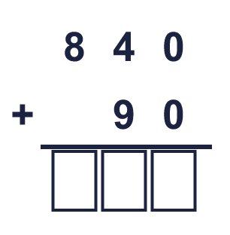
  1 | Complete the column addition. Write the missing digits in the answer.
  2 | Work out the additions.  a) 327 + 15 =  b) 518 + 12 =  c) 838 + 24 =
  2 | Work out the additions.  a) 327 + 15 =  b) 518 + 12 =  c) 838 + 24 =
  3 | Work out the additions.  a) 251 + 75 =  b) 451 + 87 =  c) 180 + 83 =
  3 | Work out the additions.  a) 251 + 75 =  b) 451 + 87 =  c) 180 + 83 =
  4 | Work out the additions.  a) 878 + 29 =  b) 558 + 89 =  c) 836 + 65 =
  4 | Work out the additions.  a) 878 + 29 =  b) 558 + 89 =  c) 836 + 65 =
  5 | Write the missing digits in the calculation.  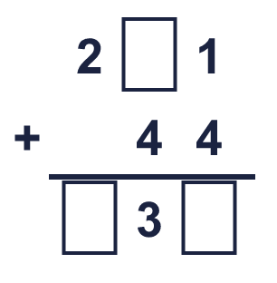
  5 | Write the missing digits in the calculation.
  6 | Work out the calculations. Write the units in your answer.  a) 660 m + 57 m =  b) 884 cm + 95 cm =  c) 576 ml + 14 ml =
  6 | Work out the calculations. Write the units in your answer.  a) 660 m + 57 m =  b) 884 cm + 95 cm =  c) 576 ml + 14 ml =
  7 | Jo has 322 books. Mia has 80 books.  a) How many books do they have altogether?  b) Jo has how many more books than Mia?
  7 | Jo has 322 books. Mia has 80 books.  a) How many books do they have altogether?  b) Jo has how many more books than Mia?
  8 | Look at the bar model. Add the parts to find the whole.  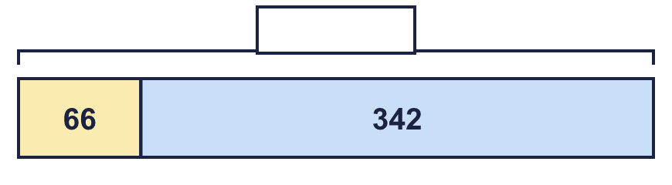
  8 | Look at the bar model. Add the parts to find the whole.

  9 | Is each calculation correct? Circle yes or no.  a) 135 + 83 = 217  Yes / No  b) 116 − 66 = 50  Yes / No  c) 455 − 63 = 393  Yes / No
  9 | Is each calculation correct? Circle yes or no.  a) 135 + 83 = 217  Yes / No  b) 116 − 66 = 50  Yes / No  c) 455 − 63 = 393  Yes / No
  10 | Is Boba correct? Circle yes or no.  Yes / No  What is the correct answer?  Explain the mistake.
     | 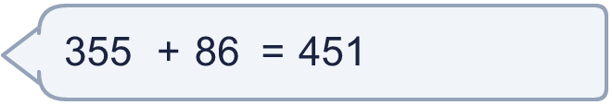
  10 | Is Boba correct? Circle yes or no.  Yes / No  What is the correct answer?  Explain the mistake.
  11 | What number did I think of?
    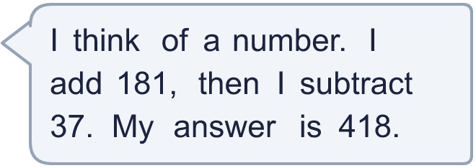
  11 | What number did I think of?
  12 | Write two different additions with an answer of exactly 300. Each has a 3-digit number and a 2-digit number.
  12 | Write two different additions with an answer of exactly 300. Each has a 3-digit number and a 2-digit number.
  13 | Max collects 345 beads. Tom collects 165 more beads than Max.  a) How many beads does Tom collect?  b) How many beads do they collect altogether?
  13 | Max collects 345 beads. Tom collects 165 more beads than Max.  a) How many beads does Tom collect?  b) How many beads do they collect altogether?
  14 | Kim uses an addition to check a subtraction. Is the subtraction correct? Circle yes or no.  574 − 170 = 404  Yes / No  Explain how you know.
  14 | Kim uses an addition to check a subtraction. Is the subtraction correct? Circle yes or no.  574 − 170 = 404  Yes / No  Explain how you know.

Year 3 · Addition and subtraction · Step 17
Add 2-digit and 3-digit numbers
Answers (teacher copy)

  1 | Complete the column addition. Write the missing digits in the answer.  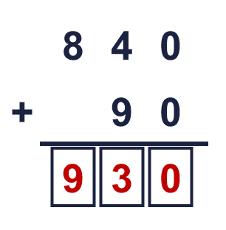  Answer: 930
  2 | Work out the additions.  a) 327 + 15 = 342  b) 518 + 12 = 530  c) 838 + 24 = 862
  3 | Work out the additions.  a) 251 + 75 = 326  b) 451 + 87 = 538  c) 180 + 83 = 263
  4 | Work out the additions.  a) 878 + 29 = 907  b) 558 + 89 = 647  c) 836 + 65 = 901
  5 | Write the missing digits in the calculation.  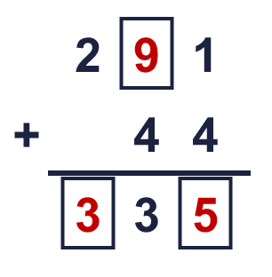  Missing digits, from top to bottom and left to right: 9 3 5
  6 | Work out the calculations. Write the units in your answer.  a) 660 m + 57 m = 717 m  b) 884 cm + 95 cm = 979 cm  c) 576 ml + 14 ml = 590 ml
  7 | Jo has 322 books. Mia has 80 books.  a) How many books do they have altogether? 402  b) Jo has how many more books than Mia? 242
  8 | Look at the bar model. Add the parts to find the whole.  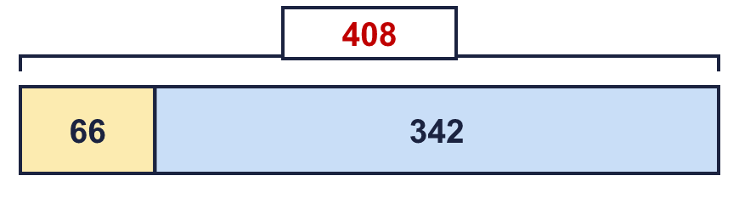  The whole is 408
  9 | Is each calculation correct? Circle yes or no.  a) 135 + 83 = 217  Yes / No  b) 116 − 66 = 50  Yes / No  c) 455 − 63 = 393  Yes / No
  10 | Is Boba correct? Circle yes or no.  Yes / No  What is the correct answer? 441  Explain the mistake.  355 + 86 = 441. The answer 451 is too big by 10.
  11 | What number did I think of? 274
  12 | Write two different additions with an answer of exactly 300. Each has a 3-digit number and a 2-digit number.  for example 278 + 22 and 246 + 54
  13 | Max collects 345 beads. Tom collects 165 more beads than Max.  a) How many beads does Tom collect? 510  b) How many beads do they collect altogether? 855
  14 | Kim uses an addition to check a subtraction. Is the subtraction correct? Circle yes or no.  574 − 170 = 404  Yes / No  Explain how you know.  404 + 170 = 574, so 574 − 170 = 404.

